***OUR LADY OF AFRICA JUNIOR SCHOOL-BUKASA***

***PRIMARY FOUR***

***MATHEMATICS***

***LESSON NOTES***

***TEACHER’S NAME: …………………………………………………………..***

***CLASS: ………………………………………………………………………….***

***STREAM: …………………………………… YEAR: ……………………….***

***TABLE OF CONTENT.***

|  |  |  |
| --- | --- | --- |
| ***NO*** | ***TOPIC/ THEME*** | ***PAGE.*** |
| ***1*** | ***TERM 1 TOPICAL BREAKDOWN*** | ***3-4*** |
| ***2*** | ***SEQUENCE AND SERIES (TYPES OF NUMBERS)*** | ***5-8*** |
| ***3*** | ***MULTIPLES AND FACTORS.*** | ***9-15*** |
| ***4*** | ***SET CONCEPTS.*** | ***16-28*** |
| ***5*** | ***OPERATION ON NUMBERS.*** | ***29-46*** |
| ***6*** | ***WHOLE NUMBERS*** | ***47-56*** |
| ***7*** | ***ROUNDING OFF*** | ***57-58*** |
| ***8*** | ***FORMATION OF NUMERALS.*** | ***59-61*** |
| ***9*** | ***ROMAN NUMERALS.*** | ***62-67*** |
| ***10*** | ***TERM 2 TOPICAL BREAKDOWN.*** | ***68-70*** |
| ***11*** | ***FRACTIONS.*** | ***71-88*** |
| ***12*** | ***DECIMAL FRACTIONS*** | ***89-99*** |
| ***13*** | ***DATA HANDLING.*** | ***99-110*** |
| ***14*** | ***GEOMETRY (SHAPES AND FIGURES)*** | ***110-119*** |
| ***15*** | ***ANGLES*** | ***120-124*** |
| ***16*** | ***CONSTRUCTION OF FIGURES AND ANGLES.*** | ***124-128*** |
| ***17*** | ***CALCULATION ON ANGLES.*** | ***129-131*** |
| ***18*** | ***TERM 3 TOPICAL BREAKDOWN.*** | ***132-134*** |
| ***19*** | ***MONEY.*** | ***135-147*** |
| ***20*** | ***TIME.*** | ***148-179*** |
| ***21*** | ***LENGTH.*** | ***180-185*** |
| ***22*** | ***PERIMETER OF FIGURES.*** | ***186-192*** |
| ***23*** | ***AREA OF FIGURES.*** | ***193-199*** |
| ***24*** | ***MASS.*** | ***200-205*** |
| ***25*** | ***CAPACITY.*** | ***206-212*** |
| ***26*** | ***ALGEBRA.*** | ***213-228*** |
| ***27*** | ***CORRECTIONS AND FINDINGS*** | ***229*** |

**PATTERNS AND SEQUENCES**

**TYPES OF NUMBERS**

* Whole numbers
* Counting numbers
* Their sequence
* Even numbers
* Their sequence
* Odd numbers
* Their sequence

**MULTIPLES**

* Finding multiples of numbers.
* Common multiples
* Lowest common multiples (L.C.M / L.C.D)

**Factors**

* Common factors
* Highest common factors (H.C.F / G.C.F)
* Lowest common factor (L.C.F)

Prime numbers

Composite numbers

**SET CONCEPTS**

**Types of sets**

* Equivalent sets
* Non equivalent
* Equal
* Empty sets (Null)
* Intersection sets
* Union sets
* Joint and Disjoint sets
* Difference of two sets
* Parts of a Venn diagram
* Shading parts of a Venn diagram
* Identifying shaded parts
* Listing numbers of elements
* Representing elements of sets on a Venn diagram

**WHOLE NUMBERS**

* Finding place values
* Finding values

**Expanding**

* Using place values
* Using values
* Using powers

**Finding expanded numbers**

* Writing numbers in words
* Writing numbers in figures
* Rounding off whole numbers
* Formation of numbers from digits
* Writing in Roman numerals
* Basic table
* Repeated numerals
* Addition
* Subtraction

Writing in Hindu – Arabic

**OPERATION ON NUMBERS**

* Addition of numbers
* Addition with and without regrouping
* Application of addition (wordy)
* Subtraction of numbers
* With and without regrouping
* Application of subtraction (wordy)
* Multiplication of numbers
* Working multiplication using repeated addition
* Application of multiplication
* Division of numbers

Working division using repeated subtraction

* Application of division (wordy)

**LESSON NOTES**

**SEQUENCES AND SERIES:**

**Sequence.**

Is a list of numbers that are in order.

**For example.**

1, 2, 3, 4, 5, …

2, 4, 8, 16, 32, …

**Series.**

Is the sum of numbers in the given sequence.

1 + 2 + 3 + 4 + 5 + …

2 + 4 + 8 + 16 + 32 + …

**Pattern:**

This is a repetition of events in a particular order.

**Note:**

Patterns form a sequence.

**Types of numbers**

**Whole numbers:**

These are positive integers including zero (o)

These are numbers that are not fractions

**Note**:

The first whole number is zero (0)

**Examples**:

0, 1, 2, 3, 4, 5, 6, 7, 8, 9, …

**Note**:

Whole numbers have a pattern of +1 and -1 in ascending and descending orders respectively.

**Counting numbers / Natural numbers:**

These are numbers that show concrete quantity of things.

**Note**:

The first counting number is one (1)

**Example**.

1, 2, 3, 4, 5, 5, 6, 7, 8, …

**Note:**

Counting numbers have a pattern of +1 in ascending order and -1 in descending order.

**Examples**

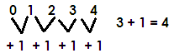Find the next number in the sequence

Or

0, 1, 2, 3, 4 (whole numbers)

Find the next numbers in the sequence.

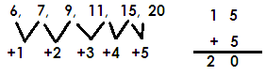

Complete the sequence below.



Find the next number in the series of;

5 + 6 + 8 + 11 + 15 + …

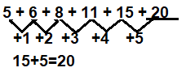

**Activity**:

1. Find the next number in the following numbers.

1. 4, 4, 5, 7, 10, _______
2. 3, 10, 7, 4, _______
3. 16, 11, 7, 4, __________
4. 3, 5, 4, 6, 5. ______

2. Find the sum of the next two numbers in the sequences below.

5, 6, 8, 11, 15, _____, _____

3. Find the next number in the following series;

a) 4 + 5 + 6 + 7 + 8 + _____

b) 31 + 30 + 28 + 25 + 21 + _____

c) 11 + 12 + 14 + 17 + 21 + 26 + _____

**Even numbers**

These are numbers that are exactly divisible by two e.g., 0, 2, 4, 6, 8, …

**Note**:

* The first even number is zero (0).
* Even numbers have a pattern of +2 in ascending and -2 in descending order.
* Any number that ends with 0, 2, 4, 6, or 8 is on even numbers.

**Odd numbers**

These are numbers that are not exactly divisible by two (2)

**Examples**:

1, 3, 5, 7, 9, …

**Note:**

Odd numbers have a pattern of plus two (+2) in ascending and minus two (-2) in descending order.

-Any number that ends with

1, 3, 5, 7, or 9 is an odd number.

**Sequence of Even and odd numbers**

**Examples:**

1. Complete the sequence below.

**Or**

0, 2, 4, 6, 8, 10 (Even numbers)

2. Find the next number in the sequence.

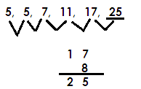3. Complete the sequence below.

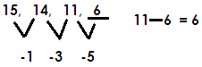4. Find the missing numbers in the sequence below.

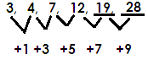5. Find the sum of the next two numbers in the sequence below.

12 +7 = 19 19 + 9 = 28

Sum = 19 + 28

= 47

6. Find the next number in the series of;

 21 + 19 + 17 + 15 + ____

**Activity:**

1. Find the next numbers in the following sequences.

1. 2, 4, 8, 14, _________
2. 6, 7, 10, 15, ___________
3. 14, 12, 8 _________

2. Find the product of the next two numbers in the sequence below.

5, 7, 9, 11, ______, __________

3. Find the product of the next two numbers in the sequence below.

20, 18, 14, ______, _______

4. Find the next numbers in the following series;

a) 11 + 13 + 15 + 17 + 19 + _____ + ______

b) 36 + 34 + 32 + 30 + 28 + _____ + ______

c) 8 + 6 + 4 + 2 + ______

**MULTIPLES**

**What are multiples?**

These are numbers got by multiplying a given number by counting numbers.

**Finding multiples of numbers**

**Examples**

1. Find the multiples of 2 less than 15.

**Solution**

2 x 1 = 2 M 2 = (2, 4, 6, 8, 10, 12, 14)

2 x 2 = 4

2 x 3 = 6

2 x 4 = 8

2 x 5 = 10

2 x 6 = 12

2 x 7 = 14

2. Find multiples of 8 between 7 and 42.

**Soln.**

8 x 1 = 8

8 x 2 = 16 M 8 = (8, 16, 24, 32, 40)

8 x 3 = 24

8 x 4 = 32

8 x 5 = 40

8 x 6 = 48

3. Find the sum of the 4th and 6th multiples of 4.

**Soln.**

4 x 1 = 4

4 x 2 = 8

4 x 3 = 12

4 x 4 = 16 4th

4 x 5 = 20

4 x 6 = 24 6th

4 x 7 = 28

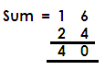

**Activity**:

1. Find multiples of 6 less than 20.

2. List the first 6 multiples of 4.

3. Find the multiples of 5 between 12 and 36.

4. List the first 4 multiples of 9.

5. Find the sum of the 3rd and the 5th multiples of 3.

6. What is the difference between the 6th and the 3rd multiples of 7?

7. Find the sum of the second (2nd) and the 4th multiples of 12.

8. Find the multiples of 2 greater than 7 and less than 19.

**FINDING COMMON MULTIPLES OF NUMBERS**

Example 1

List the first 3 common multiples of 2 and 3.

**Soln.**

M2 = (2, 4, 6, 8, 10, 12, 14, 16, 18, 20 )

M3 = (3, 6, 9, 12, 15, 18, 21, 24, 27, 30 )



Common Multiples = (6, 12, 18)

**Activity:**

1. List the first 3 common multiples of;

(a) 2 and 4 (b) 2, 3 and 4 (c) 4 and 6 (e) 4 and 8

**LOWEST COMMON MULTIPLES**

(LCM /LCD)

**Examples 1**

Find the LCM of 5 and 6.

M5 = (5, 10, 15, 20, 25, 30, 35, 40, 45, 50, …)

M6 = (6, 12, 18, 24, 30, 36, 42, 48, 54, 60, …)

Common multiples = 30 …

LCM of 5 and 6 = 30

**Activity**:

Find the LCM of the following

a. 8 and 6

b. 4 and 6

c. 12 and 8

d. 4 and 9

e. 12 and 5

f. 7 and 8

g. 12 and 20

**FACTORS**

These are numbers that can divide a given number exactly.

**FINDING FACTORS OF NUMBERS**

**NOTE**:

* One is a factor of every number.
* A number is a factor of itself.
* Factor x factor = Product

**Examples:**

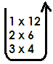1. List all the factor of 12.

F12 =



F12 = 1, 2, 3, 4, 6, 12

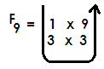2. Write all factors of 9



F9  = 1, 3, 9

**Activity:**

Write all factors of the numbers below.

1. 15 2. 25 3. 18 4. 24

5. 36 6. 48 7. 21

**FINDING COMMON FACTORS OF NUMBERS**

**Examples:**

1. Find the common factors of 12 and 20

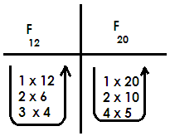**Soln.**





Common factors = (1, 2, 4)

**Activity:**

1. 6 and 8 2. 8 and 12

3. 12 and18 4. 12 and 15

5. 18 and 24 6. 20 and 30

7. 14 and 21 8. 4 and 6

9. 3 and 5 10. 10 and 20

**FINDING HIGHEST / GREATEST COMMON FACTOR**

**Examples**

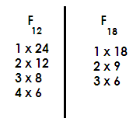Find the Greatest common factor of 18 and 24.

Common factors = 1, 2, 3, 6

= 1, 2, 3, 4, 6, 8, 12, 24

= 1, 2, 3, 6, 9, 18

GCF = 6 or HCF = 6

Find the Highest common factor of the following

1. 9 and 12

2. 8 and 12

3. 20 and 36

4. 30 and 40

5. 15 and 18

6. 9 and 21

7. 12 and 18

8. 24 and 36

9. 3 and 5

10. 5 and 7

**LOWEST COMMON FACTOR L.C.F**

**Note**:

The lowest common factor of numbers is 1

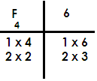Find the lowest common factor of 4 and 6.





Common factors = (1, 2)

L.C.F = 1

**PRIME NUMBERS**

Prime numbers

A prime number is a number with only two factors i.e., one and itself.

The first Prime number is two (2).

**Examples:**

(2, 3, 5, 7, 11, 13, 17, …)

**Sequence of Prime numbers.**

**Examples**

Find the next number in the sequence

2, 3, 5, 7, …

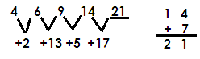Complete the sequence

**Activity:**

1. List the first six prime numbers

2. Find the sum of the 4th and 2nd prime numbers.

3. List prime numbers between 0 and 10.

4. Find the next number in the sequence below.

(a) 11, 7, 5, 3, ___________

(b) 8, 10, 13, ____________

5. Find the next number in number in the series below;

a) 2 + 3 + 5 + 7 + _____ + ______

b) 19 + 17 + 13 + 11 + ______ + _____

**COMPOSITE NUMBERS**

These are numbers with more than two factors.

The first composite number is 4.

**Example**

4, 6, 8, 9 10, 12, …

**Note:**

Composite numbers don’t have a clear pattern.

**SET CONCEPTS**

**A SET: -**

Is a collection of well-defined elements.

An element is an object or a thing that belongs in a set.

**Facts about sets**

The elements of a set must be enclosed in a curly bracket

The elements must be separated using commas e.g., set K = a, b, c

The name of a set must be written in capital letters.

**Example 1**

Given that set A = a, b, c, d

Set B = 1, 2, 3, 4

**Equivalent sets**

These are sets with the same number of elements but of different types.

Set symbols ( )

**Example**

Given that set A = a, b, c, d

B = 1, 2, 3, 4

Since set A and set B have the same number of elements.

 Set A and set B are equivalent sets

Set A Set B

**Equal sets**

These are sets with the same number of elements that are exactly the same.

Set symbol

**Example 1**

Set K = Hen, cow, dog

M = dog, Hen, Cow

Since set K and Set M have the same number and same elements,

Set K is equal to set M.

Set K = Set M

**Activity.**

Use equal or equivalent to describe the following sets.

(a) M = C, O, W and H = W, O, C

Set M __________ Set H

(b) R = a, b, c, d and H = 4, 6, 8, 9

Set R __________ Set H

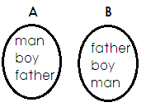(c)

Sets A ___________ Set B

(d) H = P, O, T and N = m, a, n

Set H __________ Set N

(e) R = D, R, U, M and K = M, U, R, D

Set R _________ Set K.

**Empty set / Null / void set**.

An Empty set (O) or

**Example**

Set T = whole numbers between 9 and 10

Set T is an empty set.

Set M = A pregnant father

Set M is an empty Set

**Activity**

Use empty or not empty

1. B = fish that can live on land

2. K = bulls which produce milk

3. M = Birds without wings

4. R = A class with 10 pupils

5. H = Birds which produce babies

**Intersection Sets**

Is a set of common elements in two or more sets.

Set symbol **∩**

**Examples**

1. Given that set K = Kampala, Mukono, Wakiso

M = Entebbe, Kampala, Wakiso

K ∩ M = Kampala, Wakiso

Find R n M of the sets below.

R = cow, goat, rabbits, rat

M = Hen, cow, rabbit, sheep

R ∩ M = cow, rabbit

**Activity**

1. K = Even numbers less than 10

R = Prime numbers less than 10

List members of Set

(i) K (ii) R (iii) Find K ∩ R

4. Given set H = 1, 3, 5, 7, 9

R = 0, 2, 4, 7, 5

List the common members.

5. K = , , and M = , ,

Find K ∩ M

6. Given that V = a, e, i, o, u

Z = a, b, c, d, i

Find V ∩ Z

7. Set K = 2, 3, 4, 5

Set M = 5, 6, 4, 8

Find K ∩ M

**UNION SETS**

Is a set containing all members of two or more sets.

Set symbol for union set is **U**

**Examples**

Set A = 2, 3, 4, 5

Set B = 4, 3, 6, 7

Set A U B = 2, 3, 4, 5, 6, 7

**Example: II**

Set N = , ,



Set T = , , ,



Set NUT =

**ACTIVITY:**

1. T = 2, 3, 4 K = 5, 6, 7

Find TUK.

2. M = boy, girl, man T = man, boy, teacher

Find M U T

3. A = 4, 5, 6, 7 B = 5, 8, 9, 6

Find A U B

4. Find D U E if D = a, e, i, o E = d, e, g, h

5. P = 6, 7, 8 Q = 9, 4, 5, 8

Find PUQ

6. A = y, m, n, k B = r, s, t, m

Find AUB

7. P = even numbers less than 10

K = natural numbers less than 10

Find PUK

**JOINT AND DISJOINT SETS**

Disjoint Sets are sets without common members.

**Examples of disjoint sets.**

1. Given that;

Set A = {1, 2, 3, 4, 5}

Set B = {a, b, c, d}

A∩B = { }

Therefore,

Set A and B are disjoint Sets.

**JOINT SETS / INTERSECTING SETS**

These are sets with common elements

**Examples of joint sets**

Set P = {m, e, a, t}

Set Q = {b, e, a, d}

P∩Q = {a, e}

Therefore:

Set P and Set Q are joint sets

**DIFFERENCE OF TWO SETS**

Is a set of elements that belong to only one set.

**Example**

Given set A = {2, 3, 4} and Set B = 5, 3, 4}. Find;

(ii) A-B

Set A – B = {2}

(ii) B-A

Set B – A = {5}

**ACTIVITY**

1. Set T = {odd numbers up to 7}

Set N = {even numbers up to 7}

Find T – N

Find N - T

2. T = {a, b, c, d, e}

S = {a, e, i, o, u}

Find:

1. T - s (b) S – T

2. Given that: X =



W =

Find: (a) W - X (b) X - W

3. Set R = {1, 2, 3,4, 5, 6}

Set V = {1, 3, 5, 7, 9}

Find: (a) R - V (b) V - R

4. Set K = {all even numbers less than 10}

Set L = {all odd numbers less than 10}

1. How many elements are in K – L?
2. List down all members of L – K.

5. Set M = {the first 4 multiples of 3}

Set N = {2, 3, 4, 5, 7}

Find: (a) N – M (b) M – N

**PARTS OF A VENN DIAGRAM**

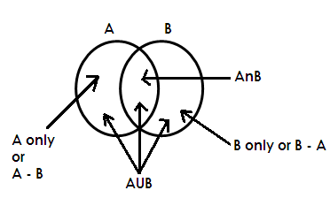Given Set A and Set B

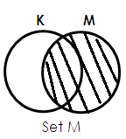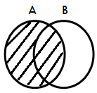**DESCRIBING SHADED PARTS OF A VENN DIAGRAM**

1. 2.

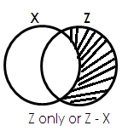 Set A

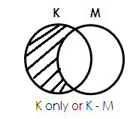

3. 4.

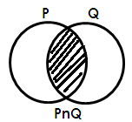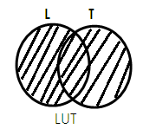

5. 6.

**ACTIVITY**

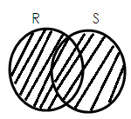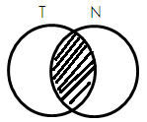1. Describe each of the shaded region in the Venn diagrams below.

(a) (b)

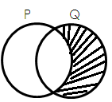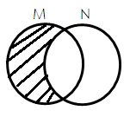

1. (d)

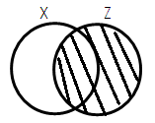 (e) (f)

2. Study and shade the Venn diagram as instructed below.

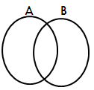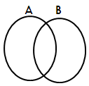 (a) Shade A∩B (b) Shade AUB

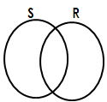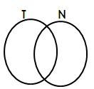 (c) Shade T – N (d) Shade R - s

1. 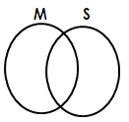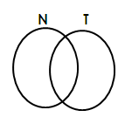Shade N U T (f)Shade M - S

**LISTING ELEMENTS IN A SET FROM VENN DIAGRAM**

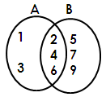Use the Venn diagram below to answer questions that follow.

Find;

(a) A∩B (b) A only (c) Set B

**Soln. Soln. Soln.**

A∩B = {2, 4, 6} A only = {1,3} Set B = {2, 4, 6, 5, 7, 9}

(d) B - A (e) AUB

**Soln. Soln.**

B – A = {5, 7, 9} AUB = {1, 2, 3, 4, 5, 6, 7, 9}

**ACTIVITY**

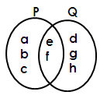1. Below is a Venn diagram, use it to answer questions that follow.

Find; (a) Set P (b) Set Q (c) P∩Q

(d) PUQ (e) P – Q (f) Q - P

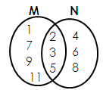2. Use the Venn diagram below to answer questions that follow.

Find; (a) Set M (b) Set N (c) M∩N

(d) MUN (e) M – N (f) N – M

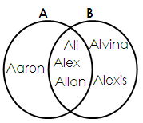3. Use the Venn diagram below to answer questions that follow.

Find; (a) Set B (b) Set A (c) A∩B

(d) AUB (e) B – A (f) A – B

**FINDING NUMBER OF ELEMNETS FROM A VENN DIAGRAM**

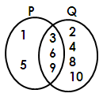Note: To find the number of elements in a Venn diagram, first list down the elements, then count to get the number.

Find; (a) n(P) (b) n(Q)

**Soln.**   **Soln.**

P = {1, 5, 3, 6, 9} Q = {2, 4, 8, 10, 3, 6, 9}

n(p) = 5 n(Q) = 7

(c) n(P∩Q) (d) n(PUQ)

**Soln. Soln.**

P n Q = {3, 6, 9} PUQ = {1, 5, 3, 6, 9, 2, 4, 8, 10}

n(P∩Q) = 3 n(PUQ) = 9

(e) n (P- Q) (f) n (Q – P)

Soln. Soln.

P – Q = {1, 5} Q – P = {2, 4, 8, 10}

n(P-Q) = 2 Therefore n(Q-P) = 4

**ACTIVITY**

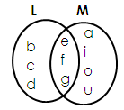1. Below is a Venn diagram. Use it to answer questions that follow.

Find; (a) n(L) (b) n(M) (c) n(L∩M) (d) n(LUM)

(e) n(L – M) (f) n(M – L)

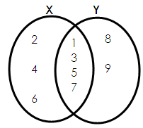2. Use the Venn diagram below to answer questions that follow.

Find; (i) n(x) (ii) n(Y) (iii) n(X∩Y)

(iv)n(XUY) (v) n(X – Y) (vi) n(Y – X)

**REPRESENTING ELEMENTS ON A VENN DIAGRAM**

**Examples:**

1. Given that; Set A = {1, 3, 5, 7, 9, 11}

Set B = {2, 3, 5, 7, 11}

Represent the above sets on the Venn diagram below;

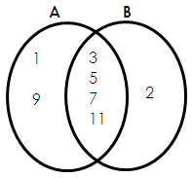

2. Is Set X = {all even numbers less than 10}

Set Y = {all counting numbers below 7}

Represent Set x and Set Y on the Venn diagram below;

**Soln.**

X = {0, 2, 4, 6, 8}

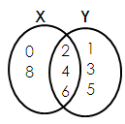 Y = {1, 2, 3, 4, 5, 6}

**ACTIVITY**

1. Given that;

Set K = {a, e, I, o, u} and Set L = {a, b, c, e, f, g, h, i}

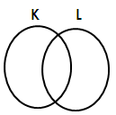 Represent the two sets on the Venn diagram below;

2. Given that;

Set P = {10, 11, 12, 13, 14, 15} Set R = {10, 12, 14, 16, 18, 20}

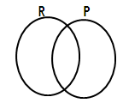 Represent set P and set R on the Venn diagram below.

3. If M = {all factors of 12} and N = {counting numbers less than 7}

Draw a Venn diagram and represent set A and set B if;

Set A = {first four prime numbers} and Set B = {1, 3, 5, 7, 9}

4. Draw a Venn diagram representing set G and set H given that;

Set G = {cow, pig, goat, cat} and Set H = {rat, lion, cat, zebra, cow}

**OPERATION ON NUMBERS**

**ADDITION OF WHOLE NUMBERS.**

**A. Without regrouping**

**Examples:**

1. Add 138736 + 421022

**Soln.**

Hth Tth Th H T O

1 3 8 7 3 6

+ 4 2 1 0 2 2

5 5 9 7 5 8

2. Work out

Th H T O

7 4 6 4

+ 2 4 2 5

9 8 8 9

**Activity:**

Add the following

1. 426 + 353 2. 1114 + 7331 3. 11210 + 2314 4. 207 + 320 + 321

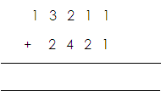

5. 3 6 4 2 5 6. 3 4 9 7 3 7.

+ 2 0 1 1 3 + 1 4 0 1 5

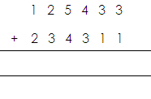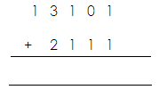8. 9.

**B. With regrouping**

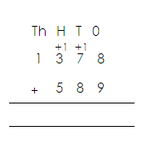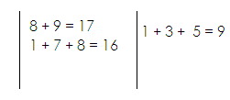 **Examples:**

1. Add:

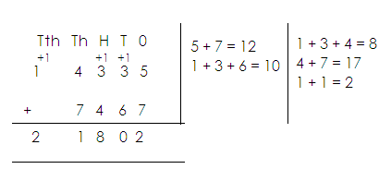2. Add:

**Activity:**

Workout the following.

1. 4 2 0 7 5 3 + 1 3 6 4 8 1 2. 2 4 5 6 + 5 3 2 + 4 0 4

3. 1 3 7 8 + 5 3 2 + 4 0 4 4. 1 4 8 3 2 + 4 2 3 8

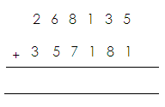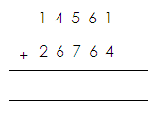5. 6.

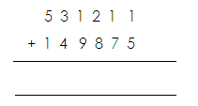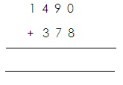

7. 8.

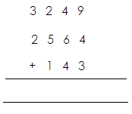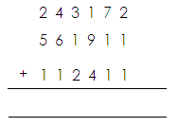

9. 10.

**WORD PROBLEMS INVOLVING ADDITION OF NUMBERS**

**NOTE:**

Sum is the answer got after addition.

**Examples**

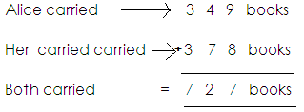1. Alice carried 349books, her brother carried 378books. How many books were carried altogether?

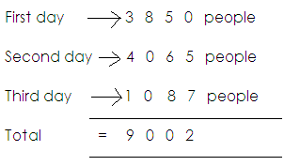2. There were 3850 people at an agriculture show on the first day. On the second day there were 4065. On the third day there were 1087 people. How many people attended the show during the three days?

**Activity:**

1. A school has 440 boys and 839 girls. How many girls are there altogether?

2. In a village, there are 804 men and 1011 women. What is the total number of adults in the village?

3. A book has 329 pages. Another book has 645 pages. How many pages do the two books have?

4. Matovu had 875 ewes, 400 rams and 175 lambs. How many sheep does he have altogether?

5. What is the sum of 3020 and 404?

6. What is 6125 plus 605?

7. Kapasi borrowed sh. 18000 from a friend, sh. 6000 from his uncle and sh. 25000 from a bank. How much money did he borrow altogether?

8. Alex is 9 years old. His brother is 15 years old. Find their total age.

**SUBTRACTION OF WHOLE NUMBERS**

**A. WITHOUT REGROUPING**

**Examples.**

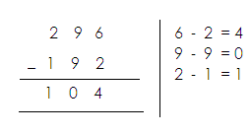1. Subtract:

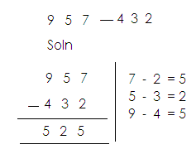2. Work out:

**Activity:**

**Subtract the following**

1. 36 – 24

2. 946 - 414

3. 4789 - 1434

4. 924735 - 30024

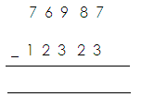5. Subtract:

**B. WITH REGROUPING**

**Examples**

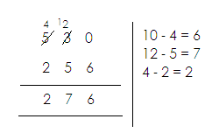1. Subtract: 6 4 6 - 5 9 2 2. Subtract: 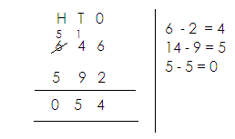

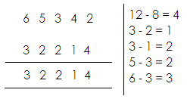

3.

**Activity:**

Subtract the following.

1. 7395 - 3826 2. 96830 - 41615 3. 28059 - 13644

4. 120 – 23 5. 7265 – 2436

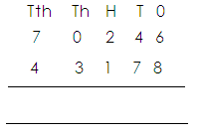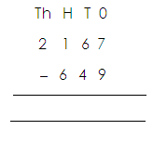6. 7.

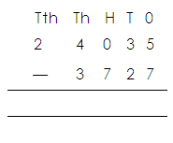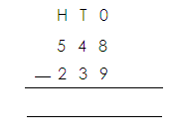8. 9.

**WORD PROBLEMS INVOLVING SUBTRACTION OF WHOLE NUMBERS**

**NOTE**:

**Difference**

Difference is the answer got after subtraction.

**Range.**

Rangeis the answer got after subtracting the lowest from the biggest.

Other key words include;

* Take away
* Subtract
* Minus
* Reduce
* Deduct
* Decrease
* Remain

**Examples**

1. What is the difference between 243 and 37?

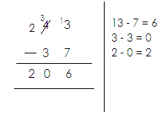 **Solution**

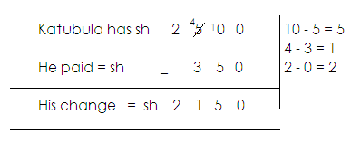2. Katabula has sh. 2500. He bought a book for sh. 350. What was his change?

3. In a school there are 1256 pupils, 578 are boys. How many are girls?

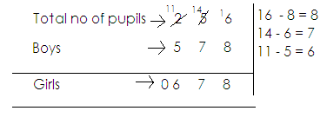 Soln.

**Activity**

1. Kibuli Demonstration School has 1000 pupils. There are 519 boys. How many girls are there?

2. Subtract 5307 from 8450.

3. Last month Onek sold 1200 of his 2350 chicken. What was he left with?

4. What is 376850 less than 140585.

5. Galiwango has sh. 24309 and Nkema has sh. 56257.

6. Take a way 53 from 111

7. What number must you add to 36 to get 176?

8. By how much is sh. 4824 greater than sh. 2248?

9. Aman had 8790 heads of cattle, 3021 were sold. How many remained?

**MAGIC SQUARE**

**NOTE:**

1. First get the magic sum.

2. The sum if all the numbers arranged in columns or rows or diagonals must be the same.

**Examples:**

1. Complete the magic square below.

|  |  |  |
| --- | --- | --- |
| 7 | a | 5 |
| b | 4 | 6 |
| 3 | c | 1 |

(a) Find the magic sum.

Magic sum = 3 + 4 + 5 or 7 + 4 + 1 or 5 + 6 + 1

= 12 = 12 = 12

(b) Find the value of a, b, and c.

|  |  |  |
| --- | --- | --- |
| 7 | a | 5 |

a = 12 – (7 + 5)

a = 12 – 12

a = 0

|  |  |  |
| --- | --- | --- |
| b | 4 | 6 |

b = 12 - (4+6)

b = 12 – 10

b = 2

|  |  |  |
| --- | --- | --- |
| 3 | c | 1 |

c = 12 – (3 + 1)

c = 12 – 4

c = 8

**Activity:**

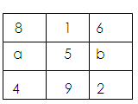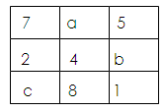Find the missing number in the magic square below.

1. 2.

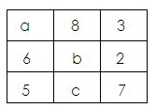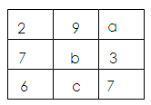

1. 4.

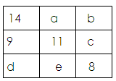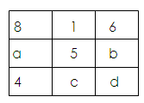5. 6.

**MULTIPLICATION (x)**

**Multiplication using repeated addition.**

**Examples:**

1. Work out 2 x4 using repeated addition.

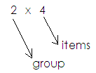 **Soln.** Therefore 2 x 4 = 4 + 4

= 8

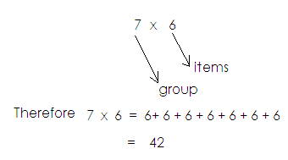2. Work out 7 x 6 using repeated addition.

3. Work out 5 + 5 + 5 + 5 using multiplication.

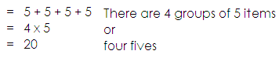 **Soln.**

**Activity**

1. Simplify the following multiplication statements using repeated addition.
2. 3 x 4 b. 2 x 7 c. 6 x 9 d. 4 x 8 c. 9 x 5
3. Work out the following addition statement using multiplication.
4. 4 + 4 + 4 + 4 + 4 + 4 b. 3 + 3 + 3 + 3 + 3 c. 7 + 7 + 7 + 7 + 7

d. 9 + 9 + 9 e. 10 + 10

**Multiplication numbers**

Two by one-digit numbers or Three by one-digit numbers.

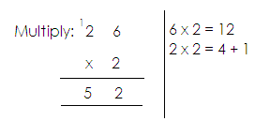**Examples:**

1.

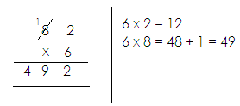2. Work out:

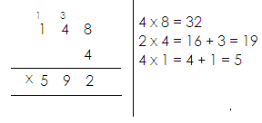3. Simplify:

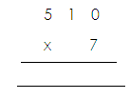**Activity:**

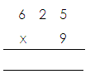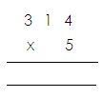Multiply the following

1. 2. 3

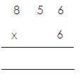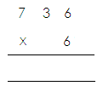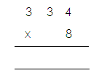4. 5 6.

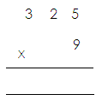

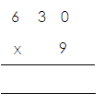 8. 9.

7.

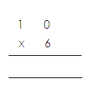

10.

**WORD PROBLEMS INVOLVING MULTIPLICATION**

Examples:

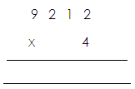1. Multiply: 9212 by 4

2. A bunch of matooke costs sh. 3900. What is the cost of 8 bunches?

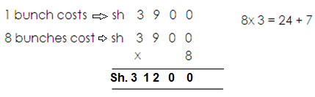

**Activity:**

1. Multiply 9314 by 3

2. What is the product of 2416 and 5?

3. What is the product of 2920 and 8?

4. I bought 4 text books at sh. 2782 each. How much did I pay?

5. A train carries 827 people. If it makes 3 trips, how many people did it carry?

6. A worker is paid sh. 6960 a day. How much will the worker get if he works for 7 days?

7. Each night the Elves made 24 pairs of shoes for the shoe maker. How many pairs of shoes did the Elves make in 128 days?

**MULTIPLICATION OF TWO DIGIT NUMBERS**

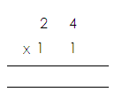 **Examples**:

1. Multiply:

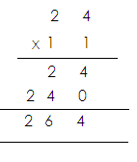

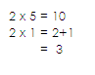 Soln

1. 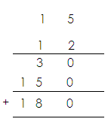Work out:

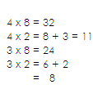

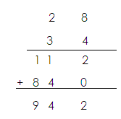 3. Multiply:

**Activity:**

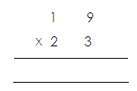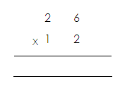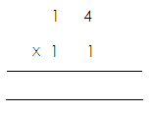Multiply the following

1. 2. 3.

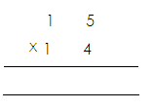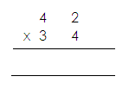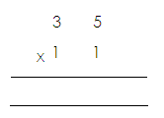4. 5. 6.

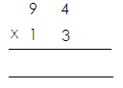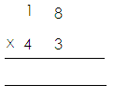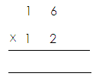7. 8. 9.

**DIVISION OF WHOLE NUMBERS**

**Division of numbers using repeated subtraction**

**Examples:**

Work out: 12 ÷ 3 using repeated subtraction

12 ÷ 3

12 – 3 = 9

9 – 3 = 6

6 – 3 = 3

3 ÷ 3 = 0

4 times

Therefore 12 ÷ 3 = 4

Workout: 15 ÷ 5 using repeated subtraction

15 – 5 = 10

10 – 5 = 5

5 - 5 = 0

3 times

Therefore: 15 ÷ 5 = 3

**Activity:**

a. 12 ÷ 2 = b. 18 ÷ 2 = c. 10 ÷ 2 = d. 20 ÷ 2 = e. 18 ÷ 2 =

f. 25 ÷ 5 = g. 36 ÷ 9 = h. 45 ÷ 9 =

**DIVISION USING LONG DIVISION**

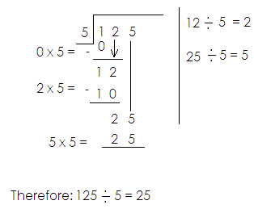1. Divide: 125 ÷ 5

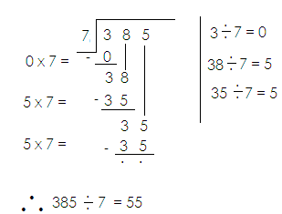2. Divide: 385 ÷ 7

**Activity:**

Divide:

1. 2. 3. 4.



5. 6.

**MORE ABOUT DIVISION OF NUMBERS USING LONG DIVISION**

Examples:

1. Divide Soln.

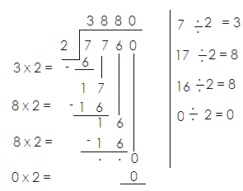

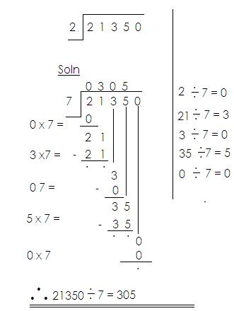2. Divide: 21350 ÷ 2

**Activity:**

Divide the following

1. 2. 3.



4. 5. 6.

**WORD PROBLEMS INVOLVING DIVISION OF NUMBERS.**

**Examples:**

1. There are 120 oranges in 2 bags. How many oranges are in each bag?

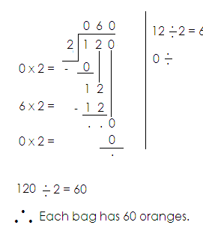 Soln.

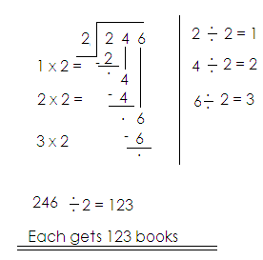2. Divide 246 text books among 2 classes.

**Activity:**

1. Divide 246 pens among 3 schools.

2. Share 246 books among 6 pupils.

3. 8 cars used 72632 litres of petrol equally. How many litres did each car use?

4. A district officer paid sh. 72000 to 10 workers. How much did each get?

5. A school bursar collected a total of sh. 46249 from 7 pupils. How much did each pay?

6. A team of 7 players was given sh. 40,047 for winning the trophy. How much was given to each player?

7. An employee received sh. 9500 after working for 5 days. How much was he paid for each day?

**WHOLE NUMBERS**

**PLACE VALUES OF WHOLE NUMBERS**

A place value is a position of a digit in given number.

**Finding place values of whole numbers.**

**Examples**

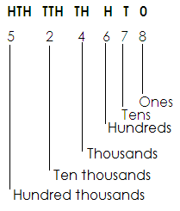Find the place value of each digit in the given number 524678.

Find the place value of the underlined digit.

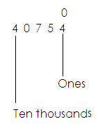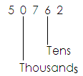(a) (b)

**Activity:**

1. Find the place value of each digit in the following.

(a) 3046 (b) 432467

2. Find the place value of 9 in the numeral 90676.

3. Find the place value of 6 in 75670.

4. Find the place value of the underlined digit in the following.

 (a) (b) 34067 (c) 70004 (d) 40346

**VALUES OF DIGITS**

A value is a product of a digit and its place value.

Value = Digit x place value

**Finding values**

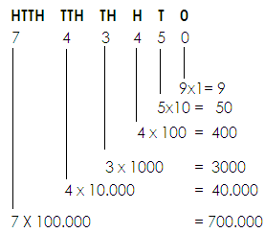1. Find the value of each digit in 743450.

2. Find the value of the underlined digit.

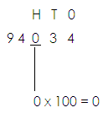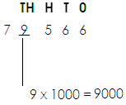 (a) (b) 7 9 5 6 6

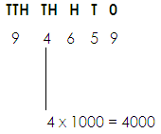3. Find the value of 4 in 94659.

**Activity:**

1. Find the value of each digit in these numbers.

(a) 403 (b) 94630 (c) 506078

2. Find the value of 0 in 50763.

3. Find the value of 5 in 65903.

4. Find the value of the underlined digit.

(a) 79034 (b) 906456

**FINDING SUM, DIFFERENCE AND PRODUCTS OF VALUES AND PLACE VALUES OF DIGITS IN A GIVEN NUMBER.**

**Examples.**

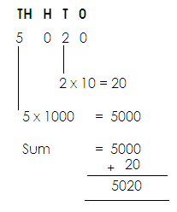Find the sum of value of 5 and value of 2 in 5020.

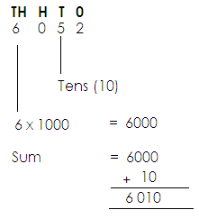Find the sum of value of 6 and place value of 5 in 6052.

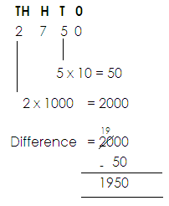2. Find the difference in the value of 2 and value of 5 in 2750.

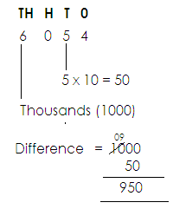3. Find the difference in the place value of 6 and value of 5 in

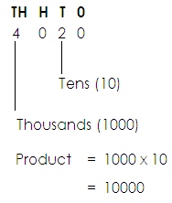4. Find the product of the place value of 4 and place value 2 in

**Activity:**

1. What is the sum of the value of 6 and 4 in the number 7641?

2. Find the sum of the value of 2 and the value of 9 in 2498.

3. What is the difference between the value of 9 and the value of 5 in the number 7905?

4. Which answer do you get when you multiply the value of 4 and the place value of 7 in 54073?

5. Work out the difference of the value of 3 and the value of 8 in the number 3841.

6. Find the product of the place value of 8 and the place value of 6 in 8697.

7. What is the difference between the place value of 4 and the place value of 3 in 547381?

**EXPANDING WHOLE NUMBERS**

**NOTE:**

Numbers are expanded in three ways;

1. Using place value

2. Values

3. Powers / exponents / indices

**USING PLACE VALUES**

**Examples**

1. Expand 394 using place values

Soln.

**H T 0**

3 9 4

(3 x 100) + (9 x 10) + (4 x 1)

2. Express 8742 in expanded form using place value

**Th H T 0**

8 7 4 2

8 thousand + 7 hundred + 4 tens + 2 ones.

**Activity:**

Express the following numbers in expanded form using place values.

1. 903 2. 7411

3. 80065 4. 87

5. 763294 6. 2635

7. 2579

**USING VALUES**

Examples:

1. Expand 3579 using values

**Soln.**

**Th H T 0**

3 5 7 9

= (3 x 1000) + (5 x 100) + (7 x 10) + (9 x 1)

= 3000 + 500 + 70 + 9

1. Express 60409 in expanded form using values.

**Tth Th H T 0**

6 0 4 0 9

= (6x 10.000) + (0 x 1000) + (4 x 100) + (0 x 10) + (9 x 1)

= 60000 + 0 + 400 + 0 + 9

**Activity**:

Expand the following using values.

1. 82 2. 709 3. 43759

4. 1094 5. 83271 6. 1991

**USING POWERS OR EXPONENTS**

A power is the number of times a quantity has to be multiplied by itself.

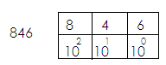**Examples**:

1.

(8x102) + (4x101) + (6x100)

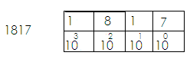2. Write 1817 in expanded form using exponents.

1817



**Activity.**

**Writing the following numbers in expanded form using indices or powers.**

1. 2772 2. 134 3. 4096 4. 94

5. 8751 6. 678 7. 70635

**WRITING EXPANDED NUMBERS AS SINGLE NUMERALS.**

**Examples:**

1. Which number has been expanded to give (3x1000) + (7x100) + (9x10) + (1x1)?

(3x1000) + (7x100) + (9x10) + (1x1)?

3000 + 700 + 90 + 1

3000

700

90

+ 1

**3,791**

2. Write 9 thousand + 6 tens + 5 ones as a single number.

9 thousand + 6 tens + 5 ones

(9x1000) + (6x10) + (5x1)

9000 + 60 + 5

9000

60

5

9065

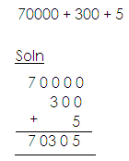3. Find the expanded number below.

4. Which number has been expanded to give (9x102) + (1x101) + (3x100)?

**Soln.**

(9x102) + (1x100) + (3 x100)

(9x10x10) + (1x10) + (3x1)

900 + 10 + 3

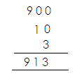

**Activity:**

Write the following as single numerals.

a. 90000 + 3000 + 40 + 50 + 8

b. (7x1000) + (4x100) + (3x10) + (2x1)

c. 4 hundreds + 7 tens

d. (2x100) + (3x10) + (5 x1)

e. (7x103) + (8x102) + (3x101) + (6x100)

f. 40000 + 8000 + 700 + 90 + 3

g. (4x102) + (5x101) + (4x100)

h. 70000 + 700 + 4

**WRITING FIGURES IN WORDS**

Examples:

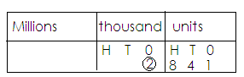1. Write 2841 in words.

Two thousand eight hundred forty – one.

2. Write 45617 in words.

|  |  |
| --- | --- |
| thousand | Units |
| H T 0  4 5 | H T 0  6 1 7 |

Forty-five thousand, six hundred seventeen.

**Activity:**

Write the following numbers in words.

a. 12,214 b. 98172

c. 99466 d. 812

e. 96 f. 98544

g. 20,086 h. 49,019

**WRITING NUMBERS IN FIGURES**

**Examples**:

1. Write: Twelve thousand eight hundred thirty-two in figures.

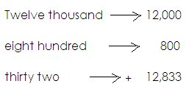 **Solution**:

2. Write: “Thirty-seven thousand, four hundred eighteen” in figures.

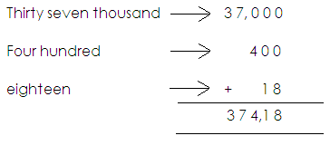 **Soln:**

**Activity:**

**Write the following in figures.**

1. Fourteen thousand, five hundred sixty-two.

2. Twenty thousand, eight hundred forty-nine.

3. Sixty-one thousand, three hundred eighty.

4. Seventy-seven thousand, eight

5. Ninety-seven thousand, one hundred ninety – nine

6. Eighty – four thousand, two hundred fifteen.

7. Seventy – two thousand five.

**ROUNDING OFF WHOLE NUMBERS**

Rounding off is the way of approximating numbers according to the nearest place value.

**NOTE**:

* When rounding off whole numbers, digits after the required place value will turn to 0.
* Base on the digit which is on the right of the figure in the mentioned place value to either round down or round up.
* If the digit on the right is 0,1, 2, 3, or 4, round down by adding 0 to the digit in the mentioned place value.
* 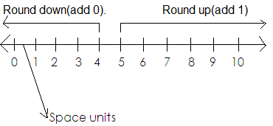If the digit on the right is 5,6,7,8 or 9, round up by adding one to the digit in the mentioned place value.

**Examples**:

1. Round off 94 to the nearest tens.

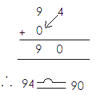 **Soln.**

2. Round off 56 to the nearest tens.

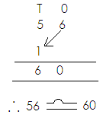 Soln

3. Round off 437 to the nearest hundreds.

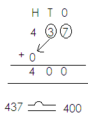 **Soln.**

4. Round off 5753 to the nearest hundreds.

**Soln.**

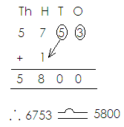

**Activity:**

1. Round off to the nearest tens.

a. 8 b. 15 c. 901

d. 97 e. 736

2. Round off the following numbers to the nearest hundreds.

a. 567 b. 937 c. 82

d. 8993 e. 8158 f. 849

**FORMATION OF NUMERALS FROM DIGITS**

**NOTE:**

* There is no number that starts with digit zero (0).
* No commas should be indicated in the numbers formed.
* When forming the smallest, arrange the given digits in ascending order without commas.
* When forming the biggest numeral, arrange the given digits in descending order without.

**Examples**:

1. Given the digit 7, 2 and 5.

a. Form the smallest digit numeral using the above digits.

**Soln.**

Smallest 257

b. Form the biggest 3-digit numeral using the above digits.

**Soln.**

Biggest 752

c. What is the sum of the smallest and the biggest numerals formed?

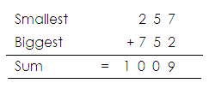  **Soln.**

d. Find the difference of the biggest and the smallest numerals formed above.

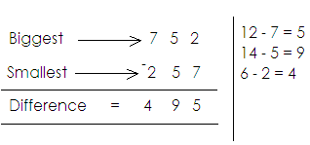 **Soln.**

2. Given the digits 8, 2,4 and 3;

a. Form the smallest digit numeral using the above digits.

**Soln.**

Smallest 2348

b. Form the biggest 4-digit numeral using the above digits.

**Soln.**

Biggest 8432

c. Find the sum of the smallest and the biggest numerals formed.

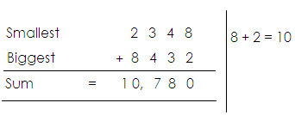 **Soln.**

d. What is the difference between the biggest and the smallest numerals formed?

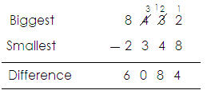 **Soln.**

3. Given the digits 6, 0 and 9. Form all the three-digit numerals using the given digits.

**Soln.**

|  |  |
| --- | --- |
| 6 | 609,690 |
| 0 |  |
| 9 | 906,960 |

The digits are: 609, 690, 906, 960

**Activity:**

1. Using digits 4, 8 and 1;

a. Form the smallest 3-digit numeral using the above digits.

b. Form the biggest 3-digit numeral using the digits above.

c. Find the sum of the smallest and the biggest numerals formed.

2. Given the digits 5, 6 and 0.

a. Form the digits 5, 6 and 0.

b. Form the biggest 3-digit numeral.

c. Find the sum of the smallest and biggest.

d. What is the difference between the biggest and the smallest?

3. Using digits 2, 7, 5 and 3;

a. Form the smallest 4-digit numeral.

b. Form the biggest 4-digit numeral.

c. Find the difference of the biggest and the smallest numerals formed.

4. Given the digits 3, 7 and 4. Form all the 3-digit numerals.

**NUMBERS AND NUMERALS**

**Number**

Number is the quantity of something.

**Numeral**

Numeral is a symbol that represents a number.

**TYPES OF NUMERALS**

There are two types of numerals.

These are:

1. Hindu Arabic numerals

2. Roman numerals

**HINDU ARABIC NUMERALS**

These are numerals that are used in most parts of the world.

**Major Hindu Arabic Numerals**

0, 1, 2, 3, 4, 5, 6, 7, 8, 9

**ROMAN NUMERALS**

**Basic Roman numeral table.**

|  |  |  |  |  |  |  |  |
| --- | --- | --- | --- | --- | --- | --- | --- |
| Hindu Arabic | 1 | 5 | 10 | 50 | 100 | 500 | 1000 |
| Roman numerals | 1 | V | X | L | C | D | M |

**NOTE:**

All roman numerals should be written in capital letters.

**Roman numerals got by repeating I**

2 = 1 + 1

= II

3 = 1 + 1 + 1

= III

**Roman numerals got by repeating X**

20 = X+X

= XX

30 = X + X + X

= XXX

**Roman numerals got by adding to 5.**

6 = 5 + 1

= VI

7 = 5 + 2

= VII

8 = 5 + 3

= VIII

**Roman numerals got by adding to 50.**

60 = 50 + 10

= LX

70 = 50 + 20

= LXX

80 = 50 + 30

= LXXX

**Roman numerals got by adding to ten**

11 = 10 + 1

= XI

12 = 10 + 2

= XII

13 = 10 + 3

= XIII

**Roman numerals got by subtracting from 5.**

4 = 5 – 1

= IV

**Roman numerals got by subtracting from 50.**

40 = 50 – 10

= XL

**Roman numerals got by subtracting from 100**

90 = 100 – 10

= XC

**Hindu Arabic and Roman numerals**

|  |  |
| --- | --- |
| **Hindu Arabic** | **Roman numerals** |
| 1  2  3  4  5  6  7  8  8  10  20  30  40  50  60  70  80  90  100 | I  II  III  IV  V  VI  VII  VIII  IX  X  XX  XXX  XL  L  LX  LXX  LXXX  XC  C |

**CHANGING HINDU ARABIC NUMERALS TO ROMAN**

**Examples:**

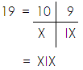1. Write 19 in Roman numerals.

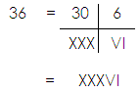2. Change 36 to Roman numerals.

**Activity:**

Write the following in Roman numerals.

1. 11 2. 13 3. 18 4. 24

5. 35 6. 38 7. 22 8. 31

9. 17 10. 40 11. 69 12. 47

**CHANGING ROMAN NUMERALS INTO HINDU ARABIC NUMERALS**

**Examples:**

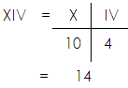1. Write XIV in Hindu Arabic numerals.

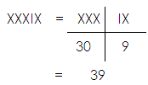3. Write XXXIX in Hindu Arabic numerals.

**Activity:**

Change these Roman numerals to Hindu Arabic numerals

1. XXII 2. XLII 3. IV 4. L

5. XXIV 6. XIX 7. XXXVII 8. VII

**WORD PROBLEMS INVOLVING ROMAN AND HINDU ARABIC NUMERALS.**

**Examples**:

1. Henry’s age is 8. Write his age in Roman numerals.

8 = VIII

2. Mukiibi’s vehicle has been driven for 24 months. Write the months in Roman numerals.

**Soln.**

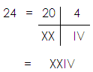

**Activity:**

1. Waiswa picked 14 mangoes. Write the number of mangoes he picked in Roman numerals.

2. Ninsima bought 30 eggs. Express the number of eggs she bought as Roman numerals.

3. These are 43 girls and 42 boys in a primary five class. Express the number of boys and that of girls as Roman numerals.

4. The numeral XXV is written on the door of my father’s office. Write that numerals in Hindu Arabic.

**ADDITION AND SUBTRACTING OF ROMAN NUMERALS**

**Addition**

**Examples**:

1. Workout: XX + VII

= 20 + 7

= 27

= XXVII

2. Workout: XX + IX

= 20 + 9

= XX + IX

= XXIX

**Subtraction**

a. Workout: XXVI – XXII b. Workout: IX - V

(30+6) – (20 – 2) = 9 - 5

= 36 – 22 = 4

= 14 = IV

= XIV

**TERM II**

**FRACTIONS**

1. Definition

2. Types of fractions

* Proper fractions changing mixed to improper
* Improper fractions
* Mixed fractions changing improper to mixed

3. Equivalent fractions

* Finding equivalent fractions
* Reducing fractions to their simplest form.

4. Arranging fractions in order

* With same denominator
* With different denominators

5. Operations on fractions

* Addition with the same denominator (proper and mixed)
* Adding fractions with the same denominator involving word problems.
* Addition with different denominators
* Addition of fractions with different denominators involving word problems.
* Subtracting with some denominator (proper and mixed)
* Subtraction with different denominators (proper and mixed)
* Subtraction with different denominators involving word problems.

**Multiplication of fractions**

Application of fractions

**Decimal fractions**

* Definition
* Place value
* Values of decimals
* Writing in words
* Writing in figures
* Changing common fractions to decimals
* Changing decimals to common fractions

**Operation on decimals**

* Addition of decimal
* Word problems on addition
* Subtraction of decimal
* Word problems on subtraction
* Arranging decimals in order

**Data handling**

* Graphs and interpretation on data.
* Tallies

**(a) Types of graphs**

* Pictographs
* Interpretation
* Drawing pictures

**(b) Bar graphs**

* Interpretations
* Drawing

**(c) Line graphs**

* Interpretation

**3. GEOMETRY**

* Simple shape (2 – dimension)
* Solid shape (3 – dimension)
* Prisms
* Pyramids

**Circle**

* Parts of a circle
* Finding radius
* Finding diameter

**Lines and angles**

(a) Lines

* Measuring lines
* Drawing lines

**(b) Angles**

* Naming angles
* Measuring angles
* Drawing angles using a protractor
* Constructing angles using a compass (900, 600)
* Constructing a square
* Constructing rectangles
* Constructing a circle

**Types of angles**

* A cute angle
* Right angles
* Obtuse angles
* Straight line

**Calculation on angles**

* Right angles
* Straight line angles

**FRACTIONS**

A fraction is part of a while.

**TYPES OF FRACTIONS**

1. Proper fractions

It is a fraction whose numerator is smaller than the denominator.

**Examples of proper fractions**

**, , ,**

**2. Improper fractions**

Is a fraction whose numerator is bigger or equal to the denominator.

**Examples of improper fractions**

**, , , ,**

**3. MIXED NUMBERS**

Is a number made up of a whole and a proper fraction.

**Changing mixed numbers to improper fractions**

Numerator

3

denominator

Whole number

**Note:**

We use the formula:

**Examples**:

1. Change 3 to an improper fraction.

 **Soln.**

 3 =



=

2. Express 7 as an improper fraction.

 **Soln.**

7 =



=



=

=

**Activity:**

Change the following mixed numbers to improper fractions.

1. 1 2. 10 3. 6 4. 5

5. 11 6. 3 7. 9 8. 1

**CHANGING IMPROPER FRACTIONS TO MIXED NUMBERS**

**Examples**

1. Write as a mixed number.

**Soln.**

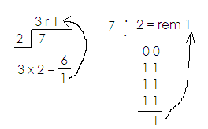 = 7 ÷ 2

=

Therefore = 3

2. Change to a mixed number.

Soln.

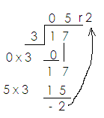 = 17 ÷ 3

1 ÷ 3 = 0

17 ÷ 3 = 5

Therefore = 5

**Activity:**

Express the following improper fractions as mixed numbers.

1. 2. 3. 4.

5. 6. 7. 8.

**EQUIVALENT FRACTIONS**

Equivalent fractions are different fractions which have the same value.

**Finding equivalent fractions.**

**Note:**

Equivalent fractions are got by multiplying the numerator and denominator by of a given fraction the same counting number.

**Examples**

1. Write the next two equivalent fractions for

**Soln.**

**= =**

**= =**

**= =**

2. Find the next equivalent fractions for .

**Soln.**

**= =**

**= =**

**= =**

**= = =**

3. Find and fill in the missing number.

**=**

**Soln.**

**= =**

**= =**

**= =**

Therefore  **=**

**ACTIVITY:**

1. Find the next two equivalent fractions for each of the fractions below.

(a) (b) (c) (d) (e)

(f) (g) (h) (i)

2. Find and fill in the missing number.

(a) = (b) = (c) =

(d) = (e) = (f) =

**Reducing fractions to their lowest terms.**

**Note**:

A lowest fraction should not have common factors between numerators and denominators.

**Examples**

Reduce to its lowest terms.

**Soln.**

**=**

**=**

** =**

Reduce to its lowest terms.

**=**

**=**

**=**

**=**

** =**

**ACTIVITY**

Reduce the following fractions to their lowest terms.

1. 2. 3. 4.

5. 6. 7.

**Arranging fractions in order**

**Note**:

Ascending order is the arrangement from smallest to biggest.

Descending order is the arrangement from biggest to smallest.

**Examples**

Arrange the following fractions in ascending order.

, ,

**Soln.**

|  |
| --- |
|  |
|  |
|  |

Required order = **, ,**

**Note:**

The fractions that give smallest shaded part is the smallest fractions

**Examples II**

Arrange  **,**  and  in descending order.

**Soln.**

|  |
| --- |
|  |
|  |
|  |

Descending order =  ***, ,***

**ACTIVITY:**

a. Arrange the following fractions in ascending order.

1. , , 2. , , 3. , , 4. , , ,

b. Arrange the following fractions in descending order.

1. , , 2. , , 3. , , ,

**OPERATIONS ON FRACTIONS**

**Addition of fractions.**

**Addition of fractions with the same denominator.**

**Examples:**

1. Add: + 2. Work out: +

**Solution Solution**

+ = + =

= =

3. Add: + + 4. Simplify: +

**Solution Solution**

+ + = = + =

= = =

= 1 =

**Activity:**

Add the following fractions.

1. + 2. + 3. + 4. + +

5. + 6. + + 7. + 8. +

**Addition of mixed numbers with same denominator.**

**Examples:**

1. Add: 1 + 4

Change to improper fractions.

= +

=

=

= 5

Work out: 2 + 3

**Solution**

Change to improper fractions.

= +

=

=

= 5

**Activity:**

Add the following

1. 2 + 1 2. 3 + 4 3. 4 + 1

4. 3 + 9 5. 8 + 9 6. 6 + 5

**Addition of fractions with same denominator involving word problems.**

**Examples:**

1. John dug of the garden and Mary dug of the garden. What part of the garden was dug?

**Solution**

John and Mary dug =  **+**

=

**=**

2. Maria ate 4 of a sugarcane yesterday and 1 of the sugarcane today. What fraction of the sugarcane was eaten?

Maria ate = 4 + 1

Altogether =  **+**

**=**

**=**

**= 5**

**Activity:**

Read and add fractions.

1. Add to

2. What is the sum of and ?

3. If Flavia sells of her land to Henry and of it to Jane. What fraction of her land has she sold?

4. Bumba ate of a cake on Monday, and on Tuesday. What fraction of the cake did he eat altogether?

5. Add: 3 cm to 4 cm.

6. Lydia had 8 kg of beans and bought 7 kg more. How many kilograms of beans does she have altogether?

7. James bought 6 kg of meat on Monday and 7 kg on Tuesday. How many kilograms did he buy altogether?

**Addition of fraction with different dominators.**

1. Add: + 2. Work out: +

Solution Solution

= x + x = x + x

= + = +

= =

=

**Activity:**

Add these fractions

1. + 2. + 3. + 4. +

5. + 6. + 7. + 8. +

**Subtraction of fraction with the same denominator.**

1. Subtraction - 2. Subtract: -

**Solution Solution**

**= - =**

**= =**

**=**

**Activity:**

1. - 2. - 3. - 4. - 5. -

6. - 7. -

**Subtraction of mixed numbers with same denominator.**

Examples:

1. Subtraction: 2. 6 + 2

4 + 2 Change to improper fraction

**Soln. Soln.**

**= - = -**

**= =**

**= =**

**= 2 = 4**

**Activity:**

Subtract the following fraction.

1. 2 - 1 2. 10 - 7 3. 4 - 1 4. 6 - 3

5. 7 - 4 6. 8 - 3 7. 8 + 3

**Subtraction of fractions with same denomination involving word problems.**

**Examples:**

1. Subtract: from 2. Alex had 7 of a cake, he ate 2 of it. What

**Soln.** fraction remained?

= -  **Soln.**

= = 7 - 2

= = -

=

= 5

**Activity:**

1. Subtract from

2. What must be added to to make ?

3. Andrew has of a cake, he ate of it. What fraction remained?

4. What remains if is subtracted from .

5. Complete the diagram below.

- =

6. If you ate of the cake, what fraction remained?

7. Subtract 3 from 2

8. Juma dug of the garden. What fraction remained?

**Subtraction of fractions with different denominator.**

**Examples:**

1. Subtract = -

**Soln.**

= -

= -

=

=

**Activity:**

Subtract the following fractions.

1. - 2. - 3. - 4. -

5. - 6. - 7. - 8. -

**Multiplication of fraction**

**Examples:**

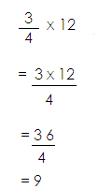1. Work out: of 6. 2. What is of 12? Or

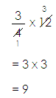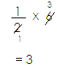 **Soln. Soln.**

=

**Activity:**

**Work out the following**

1. of 18 2. of 10

3. of 15 4. x 20

5. of 100 6. of 36

7. of 21

**APPLICATION OF FRACTIONS**

1. In a class of 40 pupils, are boys and the rest

(a) Find the girl’s fraction.

1 -

= -

=

=

(b) How many girls are in the class?

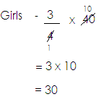 **Soln.**

1. 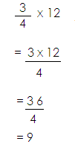 Find the number of boys.

**Soln.**

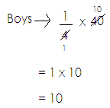

1. How many more girls than boys are in the class?

**Soln.**

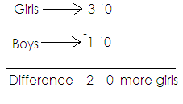

2. of the children in class use blue pens. If there are 42 children in the class, how many children use blue pens.

**Soln.**

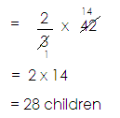 of 42

3. There are 30 balls in the box. of them are footballs and the rest are netballs.

(a) Find the fraction for net balls.

**Soln.**

= 1 -

= -

=

=

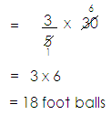 (b) How many footballs are in the box?

of 30 balls

(c) How many more foot balls than netballs are in the box?

**Soln.**

First get netballs

30 – 18

= 12 netballs

Footballs 1 8

Net balls 1 2

Difference = 0 6 more balls

**Activity:**

1. There are 6 pens in the box, of them are blue and the rest are red.

(a) Find the fraction for red pens.

(b) How many blue pens are in the box?

(c) Find the number of red pens.

2. (a) There are 8 fruits in the basket, of them are mangoes. How many fruits are mangoes?

3. Mark bought 10kg of meat, were bones and the rest were fresh.

(a) Find the fraction for the fresh.

(b) How many kilograms were bones?

(c) Find the number of kilograms for fresh.

(d) How many more kilograms were fresh than bones?

4. In a village of 60 people, are children and the rest are adults.

(a) Find the fraction for adults.

(b) How many children are in the village?

(c) Find the number of adults in the village.

5. On a farm of 100 animals, are goats and the rest are cows.

(a) Find the fraction of cows.

(b) How many goats are on the farm?

(c) How many more cows than goats are on the farm.

**DECIMAL FRACTIONS**

A number with a decimal point and decimal places.

**Place values of decimals**

**Examples**

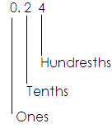Find the place value of each digit in 0.24.

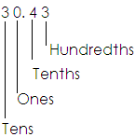Find the place value of each digit in 30.43

**Activity.**

1. Give the place value of each digit.

(a) 70.59

(b) 0.34

(c) 30.25

2. Find the place value of 6 in 45.67.

3. Fins the place value of 9 in 90.78.

4. Find the place value of the underlined digit.

(a) 97.68

(b) 30.49

(c) 907.06

**VALUES OF DECIMALS**

Value is the product of a digit and its place value.

**Note:** Values of decimals must be in decimals.

**Examples.**

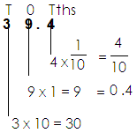Find the value of each digit in 39.4.

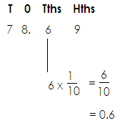Find the value of 6 in 78.69.

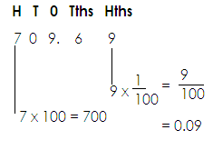Find the value of the underlined digit.

**Activity:**

1. Find the value of each digit.

(a) 39.4 (b) 34.67 (c) 706.36

2. Find the value of 2 in 49.2.

3. Find the value of 5 in 69.45.

4. Find the value of the digit in the place of hundredths.

79.68

5. Find the value of the underlined digit.

36.5

49.06

**Writing decimal numbers in words**

**Note:** The place value of the last digit must be mentioned.

**Examples**

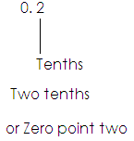1. Write 0.2 in words.

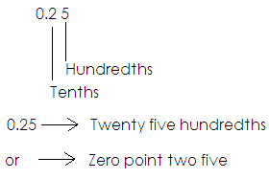Write 0.25 in words.

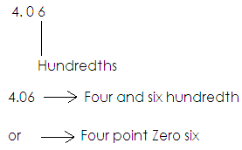Write 4.06 in words.

**Activity:**

Write the following decimal number in words.

(a) 0.5 (b) 0.46 (c) 0.18 (d) 5.3

(e) 0.76 (f) 7.04 (h) 9.42

**Writing decimal fractions in figures.**

**Examples**

1. One tenth =

= 0.1

2. Write the following in figures.

a) Six hundredths =

= 0.06

b) Eleven hundredths =

= 0.11

c) Four and six tenths = 4 and

= 4.6

**Activity:**

1. Write the following in figures.

(a) Seven tenths (b) Three hundredths

(c) One hundredths (d) Twelve hundredths

(e) Nine tenths (f) Four and nine tenths

(g) Six and twelve hundredths (h) Nine and forty-nine hundredths

**Changing common fractions to decimal.**

**Note:** The number of zeros on a denominator determines the number of decimal places in a decimal number.

Examples I

(a) Write in figures.

= 0.8

(b) Express in to decimals (2 zeros, 2 decimals)

= 0.24

(c) Express the in decimals.

= 0.5

**Activity:**

1. Express the following fractions to decimals.

(a) (b) (c) (d) (e)

(f) (g) (h) (i)

**Changing decimal numbers to common fractions.**

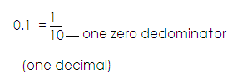 **Note:** The number of decimal places determines the number of zeros.

**Examples.**

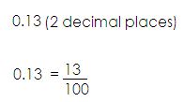Write 0.13 as a common fraction.

Express 0.34 as a common fraction.

0.34 (2 decimal places)

0.34 =

**Activity:**

Write the following decimals to fractions.

(a) 0.5 (b) 0.21

(c) 0.97 (d) 0.86

(e) 0.99 (f) 0.09

(g) 0.6 (h) 4.7

(i) 0.8

**OPERATION ON DECIMALS**

**Addition of decimals.**

**Note:** Arrange figures vertically according to place values before adding.

**Examples**

1. Add: 0.2 + 0.3

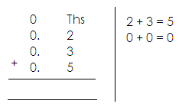 **Soln.**

2. Work out 0.2 + 0.5 using an abacus.

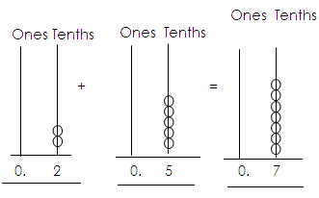 **Soln.**

**Activity:**

1. Workout the following.

1. 0.1 + 0.3 5. 0.4 + 0.5
2. 0.2 + 0.3 + 0.4 6. 0.3 + 0.5 + 0.4
3. 0.1 + 0.2 + 0.6 7. 6.5 + 0.4

4. 5.5. + 2.1

2. Add the following using abacus.

1. 3.2 + 4.6 2. 2.2. + 3.2 3. 7.3 + 3.5 4. 0.7 + 0.

5. 3.2 + 1.4 6. 0.4 + 5.3 7. 1.1 + 2.7

**Addition of decimals involving word problems.**

**Examples**

1. 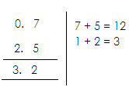What is the sum of 0.7 and 2.5?

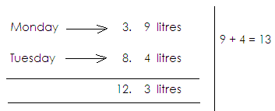A pupil drank 3.9 litres of milk on Monday and 8.4 on Tuesday. How many litres of milk were drank altogether.

**Activity:**

1. What is the sum of 3.5 and 2.5?

2. A rectangular garden measures 14.3 metres by 8.9 metres. What is the distance round it?

3. Mbabazi bought 2.5 metres of cloth. He bought 1.5 metres more for a shirt. How many metres pf cloth did he buy altogether?

4. A car used 15.5 litres of petrol on Monday and 12.8 litres the next day. How much petrol was used altogether?

5. Tony bought 2.5 metres of ribbon. Agiyo bought 1.5 metres. What length of ribbon do they have altogether?

**SUBTRACTION OF DECIMALS**

Examples:

1. Subtract: 0.5 – 0.2 2. Subtract: 33 - 16

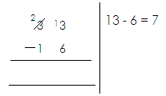 **Soln. Soln.**

1. 5
2. 2
3. 3

**Activity:**

Subtract the following decimals.

1. 0.7 – 0.1 2. 0.5 – 0.2

3. 0.9 – 0.6 4. 4.9 – 12

5. 7.4 – 2.0 6. 0.6 – 0.5

7. 4.2 – 1.8 8. 6.4 – 2.7

9. 5.0 – 1.8 10. 5.1 – 3.8

**WORD PROBLEMS INVOLVING SUBTRACTION OF DECIMALS.**

**Examples:**

1. Aisha had 7.2 metres of a string. She sold 3.5 metres. What length of the string did she remain with?

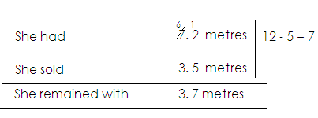 **Soln.**

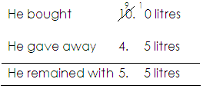2. Musoke bought 10 litres of cooking oil. He gave away 4.5 litres. How much litres of cooking oil did he remain with?

**Activity:**

1. Mbabazi had 3.5 litres of cloth. She cut off 1.8 metres. What length of the cloth was left?

2. A trader made 5.3 litres of juice. He sold 2.8 litres. How many litres of juice remained?

3. Father bought 8.5 kg of meat. He gave 2.9kg to grandmother. How many kg were left?

4. A roll of cloth measured 24.6 metres. A trader sold 13.8 metres. What length of the cloth was left?

5. Adyebo bought 18.3 litres of petrol. He used 13.8 litres. How many litres remained?

6. Nakato weighs 15.2kg. Wasswa weighs 17.1 kg. Find the difference between their weight.

**ORDERING DECIMAL FRACTIONS**

**NOTE:**

First change the decimals to common fractions.

**Examples:**

1. Arrange 0.6, 0.2, 0.4 starting with the smallest.

Soln.

0.6 -

0.2 -

0.4 -

The order is , ,

2. Arrange 0.4, 0.8, 0.3 starting with the biggest.

**Soln.**

0.4 -

0.8 -

0.3 -

Therefore, the order is , ,

**Or**

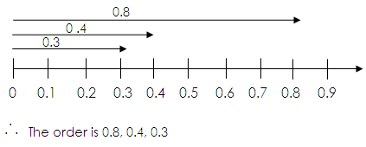 Using a number line.

**Activity:**

1. Arrange these decimal fractions starting with the smallest.

(a) 0.5, 0.1, 0.3 (b) 0.8, 0.3. 0.5

(c) 0.4, 4. 0.04 (d) 0.2, 2.2, 0.3, 0.7

(e) 0.7, 0.2, 0.4 (f) 0.3, 0.1, 0.7, 0.9

2. Arrange the following starting with the largest.

1. 0.3, 0.7, 0.2 2. 0.4, 0.4, 0.04

3. 0.9, 0.1, 0.5, 0.7 4. 0.7, 0.2, 0.5, 0.8

5. 0.5, 5, 0.5, 0.05 6. 0.1, 0.9, 0.4, 0.2

**DATA HANDLING**

**GRAPHS AND INTERPRETATION OF DATA.**

A graph is a picture or a diagram used to show facts or numbers.

**TALLIES**

Tallies are marks used to count and group things in five.

**Examples:**

1. 1

2. 2

3. 3

4. 4

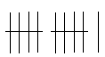5. 5

6. 11

7. 15

**Activity:**

1. Study and complete the tally marks.

 a.

 b.

 c.

 d.

 e.

 f.

 g.

h.

2. The table shows colours of different cars that were counted by pupils during break-time for 5 days. Use it to answer the questions that follow.

|  |  |  |  |  |
| --- | --- | --- | --- | --- |
| **Days of the week** | **White** | **Red** | **Black** | **Maroon** |
| Monday |  |  |  |  |
| Tuesday |  |  |  |  |
| Wednesday |  |  |  |  |
| Thursday |  |  |  |  |
| Friday |  |  |  |  |

1. How many cars were counted on Monday?

(b) How many maroon cars were counted on Wednesday?

(c) What day was the largest number of cars counted?

(d) Which colours has the fewest numbers of cars?

(e) What is the total number of the white cars?

(f) What is the total number of cars counted on Monday and Tuesday?

3. Complete the tally table below.

|  |  |
| --- | --- |
| **Marks** | **Tallies** |
| _________ |  |
| 13 | __________ |
| ___________ |  |
| 20 | __________ |

**PICTOGRAPHS OR PICTURE GRAPHS**

A pictograph is a graph where pictures represent quantity.

**SCALE INTERPRETATION**

**Examples**:

****1. If represents 5 chairs, how many chairs are represented by

?

 **Soln.**

 1 picture 5 5 chairs

 7 pictures 7 x 5 chairs 35 chairs

2. If 7 balls = , then draw pictures to represent 42 balls.

**Soln.**

7 balls = 1 picture.

42 balls = 42 balls ÷ 7

6 pictures

 42 balls =

3. If 4 trees are represented by , how many pictures represent 24 trees.

**Soln.**

4 trees = 1 picture

24 trees = 24 trees ÷ 4

= 6 pictures

**Activity:**

1. Given that represents 10 fish, how many fish are represented by

?



2. If represents 9 books, how many books are represented by

?

3. Given that represents 5 cups. How many cups are represented by 35 cups?

4. If represents 8 boxes, how many pictures of boxes are represented by 48 boxes?



5. If represents 7 flowers, draw pictures to represent 35 flowers?

6. Given that represents 6 chairs, draw pictures to represent 24 chairs.

**INTERPRETATION OF PICTOGRAPHS**

**Example:**

1. Below are some pictographs.

Four farmers; Akullo, Kam, Kiiza and Jovan planted trees on their farms.

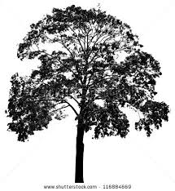 Each tree represents 10 trees.

= 10 trees

|  |  |  |
| --- | --- | --- |
| Akullo | https://encrypted-tbn1.gstatic.com/images?q=tbn:ANd9GcRnE53iGzcMlbuynk94V_C9YZXmhaVV4pa6L1fFqZCMVGlWhec9 | 10 |
| Kam | https://encrypted-tbn1.gstatic.com/images?q=tbn:ANd9GcRnE53iGzcMlbuynk94V_C9YZXmhaVV4pa6L1fFqZCMVGlWhec9https://encrypted-tbn1.gstatic.com/images?q=tbn:ANd9GcRnE53iGzcMlbuynk94V_C9YZXmhaVV4pa6L1fFqZCMVGlWhec9https://encrypted-tbn1.gstatic.com/images?q=tbn:ANd9GcRnE53iGzcMlbuynk94V_C9YZXmhaVV4pa6L1fFqZCMVGlWhec9 | 30 |
| Kiiza | https://encrypted-tbn1.gstatic.com/images?q=tbn:ANd9GcRnE53iGzcMlbuynk94V_C9YZXmhaVV4pa6L1fFqZCMVGlWhec9https://encrypted-tbn1.gstatic.com/images?q=tbn:ANd9GcRnE53iGzcMlbuynk94V_C9YZXmhaVV4pa6L1fFqZCMVGlWhec9https://encrypted-tbn1.gstatic.com/images?q=tbn:ANd9GcRnE53iGzcMlbuynk94V_C9YZXmhaVV4pa6L1fFqZCMVGlWhec9https://encrypted-tbn1.gstatic.com/images?q=tbn:ANd9GcRnE53iGzcMlbuynk94V_C9YZXmhaVV4pa6L1fFqZCMVGlWhec9https://encrypted-tbn1.gstatic.com/images?q=tbn:ANd9GcRnE53iGzcMlbuynk94V_C9YZXmhaVV4pa6L1fFqZCMVGlWhec9 | 50 |
| Jovan | https://encrypted-tbn1.gstatic.com/images?q=tbn:ANd9GcRnE53iGzcMlbuynk94V_C9YZXmhaVV4pa6L1fFqZCMVGlWhec9https://encrypted-tbn1.gstatic.com/images?q=tbn:ANd9GcRnE53iGzcMlbuynk94V_C9YZXmhaVV4pa6L1fFqZCMVGlWhec9https://encrypted-tbn1.gstatic.com/images?q=tbn:ANd9GcRnE53iGzcMlbuynk94V_C9YZXmhaVV4pa6L1fFqZCMVGlWhec9https://encrypted-tbn1.gstatic.com/images?q=tbn:ANd9GcRnE53iGzcMlbuynk94V_C9YZXmhaVV4pa6L1fFqZCMVGlWhec9https://encrypted-tbn1.gstatic.com/images?q=tbn:ANd9GcRnE53iGzcMlbuynk94V_C9YZXmhaVV4pa6L1fFqZCMVGlWhec9https://encrypted-tbn1.gstatic.com/images?q=tbn:ANd9GcRnE53iGzcMlbuynk94V_C9YZXmhaVV4pa6L1fFqZCMVGlWhec9https://encrypted-tbn1.gstatic.com/images?q=tbn:ANd9GcRnE53iGzcMlbuynk94V_C9YZXmhaVV4pa6L1fFqZCMVGlWhec9 | 70 |

1 x 10 = 10 5 x 10 trees

3 x 10 = 30 7 x 10 = 70

1. How many trees does Kiiza have?

**Soln.**

1 picture =10

5 picture = 5 x 10 trees

= 50 trees

1. Find the number of trees Jovan planted.

Soln.

7 x 10

= 70 trees

1. Who has the least number of trees?

Soln.

Akullo

**Activity:**

1. The graph below shows the number of balls picked by four sisters from a shop.

|  |  |
| --- | --- |
| Doreen |  |
| Diana |  |
| Daphine |  |
| Daizy |  |

represents 5 balls

1. Which two sisters picked the same number of balls?

(b) Who picked the largest number of balls?

(c) How many balls did they pick altogether?

(d) Who picked the smallest number of balls?

(e) If each ball costs sh. 1000

(i) How much would Diana pay?

(ii) How much would Daphine pay?

2. Study the pictograph below and answer the questions that follow.

|  |  |
| --- | --- |
| Sunday |  |
| Monday |  |
| Tuesday |  |
| Wednesday |  |



= 6 fish

= 6 fish,

(a) How many fish were sold on Monday?

(b) Which day was the biggest number of fish sold?

(c) Find the difference between the biggest and the smallest number of fish sold?

(d) If each fish was sold at sh. 800, how much money was earned on Wednesday?

(e) How many fish were sold on Tuesday?

**Drawing pictographs**

**Examples:**

1. Draw a pictograph to show that

Peter has 6 stools.

Tony has 10 stools

Richard has 14 stools

Chris has 8 stools

Isaac has 4 stools

**Solution**

Peter 6 ÷ 2 = 3 pictures

Tony 10 ÷ 2 = 5 pictures

Richard 14 ÷ 2 = 7 pictures

Chris 8 ÷2 = 4 pictures

Isaac 4 ÷ 2 = 2 pictures.

|  |  |
| --- | --- |
| Peter |  |
| Tony |  |
| Richard |  |
| Chris |  |
| Isaac |  |

**Activity:**

1. Make a pictograph for the following information.

John has 12 books

Mega has 15 books

Sarah has 18 books

Kemisi has 9 books

Scale: = 3 books

2. Four farmers harvested mangoes and got the following number of mangoes.

Suzan 30 mangoes, Rebecca 24 mangoes, Wilber 15 mangoes and John 40 mangoes.

 Draw a pictograph to represent the information above.

Scale: = 5 mangoes

**BAR GRAPHS**

A bar graph is a graph where we use columns or blocks to represent quantity or information.

**INTERPRETATION OF BAR GRAPH**

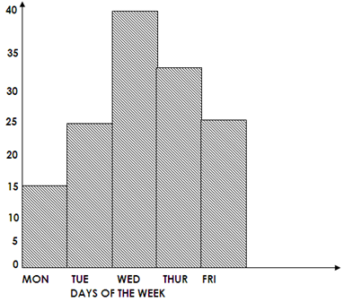The table below shows the daily attendance of P.4 pupils for a week. Study it and answer the following questions.

NUMBER OF PUPILS

1. How many pupils were present on Thursday?

30 pupils

2. Which days had the same number of pupils present?

Tuesday and Friday

3. Which day had the biggest number of pupils present?

Wednesday

4. Find the total attendance that week.

**Soln.**

Monday - 1 5

Tuesday - 2 5

Wednesday - 4 0

Thursday - 3 0

Friday - 2 5

**Total - 1 3 5 pupils**

**Activity:**

1. The graph below shows the number of radios sold by Mr. Jjonjo. Study it and answer the questions below.

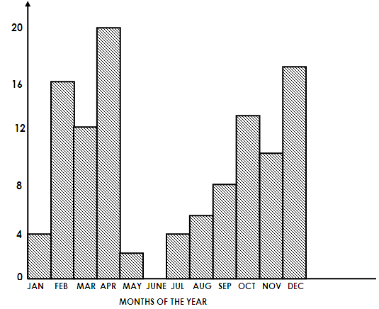

**Number of radios**

1. How many radios were sold in March?
2. In which month did Jjojjo sell no radios?
3. Which month had the highest number of radios sold?
4. How many more radios were sold in January than May?
5. How many radios were sold in the first six month?
6. How many radios were sold in the year?

**Drawing and completing bar graph**

**Examples:**

1. A lorry carried bags of sugar, tins of kimbo, cartons of books, crates of soda and cartons of matches to Mr. Rebecca’s shop as shown in the table below.

|  |  |  |  |  |  |
| --- | --- | --- | --- | --- | --- |
| Item | Crates of soda | Boxes of books | Bags of sugar | Tins of kimbo | Cartons of matches |
| Number | 13 | 12 | 5 | 11 | 7 |

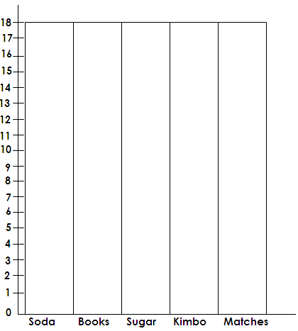 Show the same information on a bar graph.

**Activity:**

1. A school boy recorded the number of motor cycles that passed by his home in one week.

|  |  |  |  |  |  |  |  |
| --- | --- | --- | --- | --- | --- | --- | --- |
| **Days of the week** | **MON** | **TUE** | **WED** | **THUR** | **FRI** | **SAT** | **SUN** |
| No. of motor cycles | 15 | 20 | 10 | 20 | 25 | 30 | 5 |

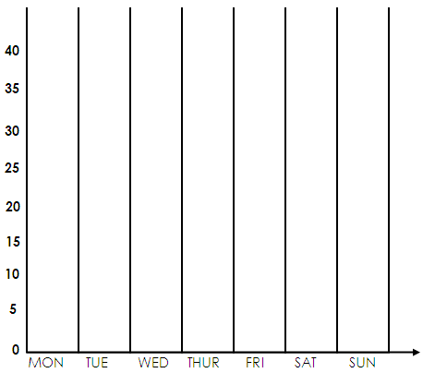a. Use the information in the table to draw a bar graph.

b. (i) How many motorcycles were recorded in the first two days of the week?

(ii) Which days had the same number of motor cycles recorded?

(iii) What was the total number of motorcycles in the first three days?

(iv) How many motor cycles were recorded on Friday, Saturday and Sunday?

(v) Which days had the same number of motor cycles recorded?

**GEOMETRY**

* Geometry is a branch of mathematics that deals with lines, angles and figures.
* Is the idea of drawing and constructing lines, angles and figures.

**SIMPLE SHAPE OR TWO DIMENSIONAL**

Two-dimensional shapes are shapes that show two sides or faces at the same time.

**Examples of 2-demensional shapes or figures**

|  |  |  |  |
| --- | --- | --- | --- |
|  | **Name** | **Shape** | **Property** |
| 1. | Rectangle |  | * Has two opposite sides equal. * Has 4 right angles. * Has 2 folding lines of symmetry. |
| 2. | Square |  | * Has all 4 sides equal. * Has 4 right angles. * Has 4 lines of folding symmetry |
| 3.  a. | Triangle  Equilateral  triangle |  | * Has all 3 sides equal. * All 3 interior angles are equal. * Has 3 lines of folding symmetry. |
| b. | Right angles triangle |  | * Has one interior right angle. * Has no lines of folding symmetry. |
| c. | Isosceles triangle |  | * Has two adjacent lines angle. * Has two base angles equal. * One line of folding symmetry. |
| d. | Scalene triangle |  | * Has different interior angles in size. * Has no lines of folding. * Has different lines in length. |
| 4. | Kite |  | * Has two adjacent lines. * Has one line of folding symmetry. |

|  |  |  |  |
| --- | --- | --- | --- |
| 5.  a. | Trapeziums  Right angles  trapezium |  | * Has two interior right angles. * Has no lines of folding symmetry? |
| b. | Isosceles  trapezium |  | * Has 2 opposite standing lines equal. * Has one line of folding symmetry. |
| 6. | Parallelogram |  | * Two opposite sides are parallel and equal. * Has two opposite angles equal. * Has no lines of folding. |
| 7. | Rhombus |  | * Has two opposite parallel. * Has two lines of folding symmetry. * Has two opposite <s equal. |

**SOLID SHAPES OR THREE-DIMENSIONAL SHAPES.**

Three dimensional shapes are shapes that can show three sides at the same time.

**Examples of three-dimensional figures.**

**A. PRISMS**

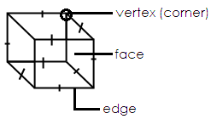1. Cube

* A cube has 6 faces.
* It has 8 vertices or corners.
* It has 12 edges
* It is made up of square faces.

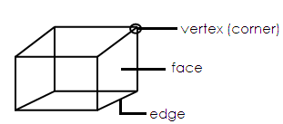2. Cuboid

* A cuboid is made up of rectangular faces.
* Has 6 faces, 8 vertices and 12 edges.

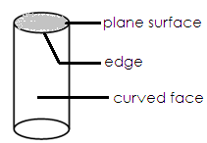3. Cylinder

* Has two circular ends.
* Has 3 faces
* Has two edges.

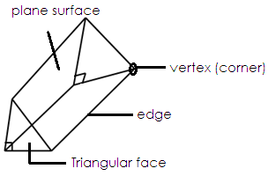4. Triangular Prism

* Has two triangular faces

5 faces altogether

* Has 3 rectangular faces
* Has 9 edges
* Has 6 vertices

**B. PYRAMIDS**

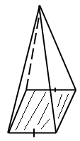1. Square Pyramid

* Has 5 faces
* Has 5 vertices
* Has 8 edges

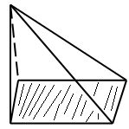2. Rectangular Pyramid

* Has 5 faces
* Has 5 vertices
* Has 8 edges

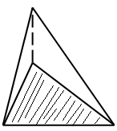3. Triangular Pyramid

* Has 4 faces
* Has 4 vertices
* Has 6 edges.

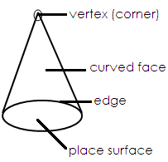4. Cone

* A cone has two faces
* Has one vertex
* Has one edge.

**Activity:**

**CIRCLES**

A circle is a curved surface.

A circle

**PARTS OF A CIRCLE**

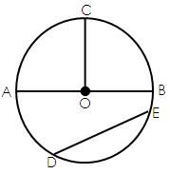

1. OC is the radius

But:

OC = AO + OB

2. AB is the Diameter

3. DE is the chord

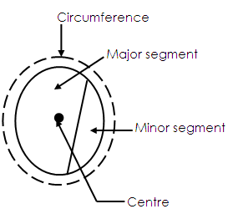

1. Radius

Is the line from the centre of the circle to its circumference.

2. Diameter

Is a line joining two ends of the circumference through the centre.

3. Circumference

Is the distance round circular objects.

4. Chord

Is any line joining two ends of the circumference.

5. Sector

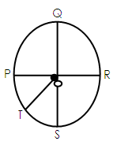**Activity:**

1. a. Name the part of a circle marked O.

b. Name all the radii shown on the circle.

OS _____________ OR ____________

QS ____________ PR _____________

Name all the diameter you can see on the circle.

(i) ……………………….. (ii) …………………………

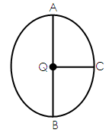2. Use the circle below to answer questions that follow.

a. From the circle above, measure the length of the radius.

OA = _______cm OR = ________cm OC = ___________cm

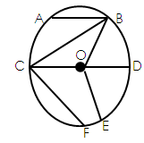3. Name the line

a. AB is a __________ b. OE is a ___________

c. CD is a __________ d. CF is a ___________

e. OD is a __________ f. OB is a _________

g. OC is a ___________h. CB is a __________

**FINDING THE LENGTH OF THE DIAMETER OR THE RADIUS**

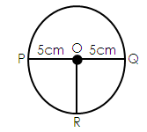 Diameter PQ = 10cm

Radius OR = 5cm

NOTE: Diameter is twice the radius

Diameter = 2 x r or r + r

Radius = D ÷ 2

**Examples:**

1. If the radius of a circle is 7cm, find the diameter of the circle.

Diameter = 2 x r Therefore diameter = 14cm

= 2 x 7cm

2. Find the radius of a circle whose diameter is 30cm.

**Soln.**

Radius = D ÷ 2

Radius = 30cm ÷ 2

Radius = 15cm

**Activity:**

1. Find the diameter of a circle whose diameter is;

a. 10cm b. 8dm c. 24cm d. 48cm

e. 60cm f. 100cm g. 34cm h. 12cm

2. Find the radius of a circle if the diameter is:

a. 20cm b. 18cm c. 16cm

d. 48cm e. 36dm

3. Complete the tables below.

a)

|  |  |  |  |  |  |  |  |  |  |  |
| --- | --- | --- | --- | --- | --- | --- | --- | --- | --- | --- |
| Radius | 2cm | 6cm | 7cm | 9cm | 10cm | 13cm | 14cm | 15cm | 16cm | _____ |
| Diameter | 4cm | ____ | _____ | ____ | _____ | ____ | _____ | ____ | _____ | _____ |

b)

|  |  |  |  |  |  |  |  |
| --- | --- | --- | --- | --- | --- | --- | --- |
| Radius | ____ | _____ | ____ | _____ | ____ | _____ | _____ |
| Diameter | 8cm | 10cm | 24cm | 40cm | 44cm | 70cm | 90cm |

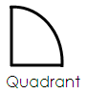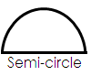**OTHER PARTS OF A CIRCLE**

**LINES AND ANGLES**

A line is distance between any two points.

**Measuring lines**

**Examples**:

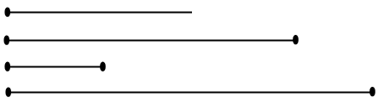Measure the following lines.

a.

b.

c.

d.

**Drawing lines**

**Examples**:

Using a ruler and a sharp pencil, draw the following lines.

1. 2cm b. 5cm
2. c. 12cm d. 7.5cm
3. e. 1cm f. 9cm
4. g. 3.5cm

**ANGLES**

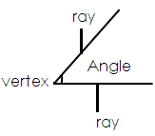 Is the amount of turning between two straight lines at a fixed point i.e.

**Naming Angles**

**Examples:**

1. 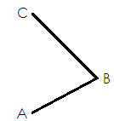Name the angle below.

The Angle is ABC or CBA

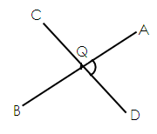 2. Study the angles formed.

The point of intersection is Q. The angles formed are;

(i) AQD or DQA (ii) AQC or CQA

(iii) DQB or BQD

**Activity:**

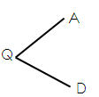Name the following angles below.

1. b.

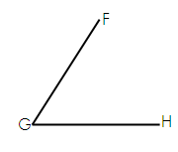Angle ____________ Angle ____________

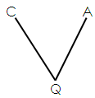 c) d.

Angle ______________ Angle ______________

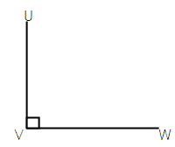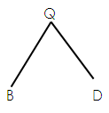

e. f.

Angle _____________ Angle ____________

**Measuring Angles**

Ask learners to draw angles of their own choice.

Ask them to measure angles drawn.

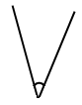**Measure the angles below.**

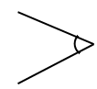

1. b.

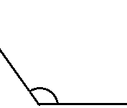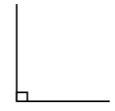 d. e.

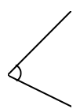

f.

**Drawing Angles using a protractor.**

Guide learners to draw angles using a protractor.

**Activity:**

Draw angles below.

1. 650 2. 400 3. 250 4. 700

5. 100 6. 1400 7. 900 8. 500

9. 700 10. 1300 11. 800 12. 750

**Constructing angles using a compass**.

1. **An angle of 900**

In construction, drawing is done in pencil and writing in ink.

Steps:

* Use a ruler, a compass and a pencil only.
* Draw a base line and mark a point A on it.
* Use a point as a stand, open the pair of a compass mark 2 arcs on either sides of the point.

**Activity:**

Constructing an angle of 900

* Using the arcs, draw above point A intersecting each other at point C.
* Join A to C
* The angle formed is 900

**An angle of 600**

1. On a line, mark off point 0

2. Use 0 as the stand, point mark ark on the line and the other slight above.

3. Then use the arc on the line as the stand point, draw another arc stand point, draw another arc to intersect the one above.

**Steps:**

1. Draw a line and mark

2. Using a pair of a compass with radius less than the line drawn, draw two ones, arc 1 to cut the line at point and another arc, arc 2 above the base line as shown below.

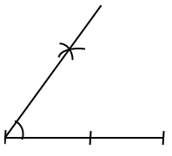

**Activity:**

Using a pencil, a ruler and a pair of compasses, construct the following angles.

a) 60**0**

b) 90**0**

**CONSTRUCTING A SQUARE**

Take learners through the steps.

**Examples**

Using a sharp pencil, a ruler and a pair of compasses only, construct a square of side 5cm.

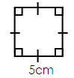**Sketch**

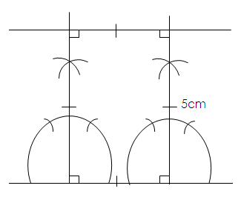**Accurate diagram.**

**Activity:**

2. Using a sharp pencil, a ruler and a compass, construct a square of sides 6cm.

**CONSTRUCTING A RECTANGLE**

Guide learners through the correct steps of constructing a rectangle.

**Examples.**

Use a ruler, a sharp pencil and a pair of compasses only, construct a rectangle ABCD of length 7cm and with 5cm.

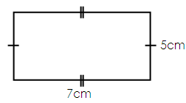 **Sketch**

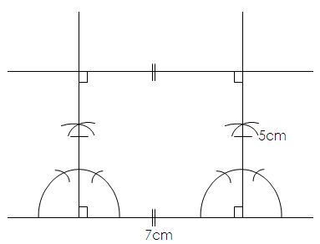 **Accurate diagram**

**CONTRUCTING A CIRCLE**

* Measure the given radius
* Identify the centre or starting point.
* Roll the compass using the given radius to make a circle.

**Example**

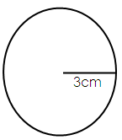 Draw a circle of radius 3cm.

Radius = 3cm

Diameter = 6cm

**Activity:**

Draw a circle of radius.

1. 4cm b. 3cm
2. c. 5cm d. 6cm

**TYPES OF ANGLES**

a. Acute angles

These are angles that measure less than 90**0**.

**e.g.,** 200, 300, 180, 490, 700, 890, 620, 10 etc.

the smallest acute angle is 1**0** and the largest acute angle is 89**0**.

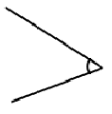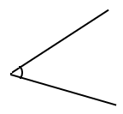**Illustration.**

**b. Right angle**

A right angle is an angle that measures exactly 900.

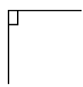**Illustration.**

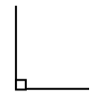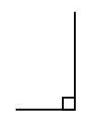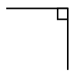

**c. Obtuse angles.**

Obtuse angles are angles which are greater than 900 but less than 1800.

**Examples.**

910, 950, 1000, 1200, 1300, 1490, 1790, 1600, etc.

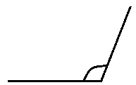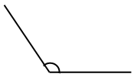 **Illustration**

**d. Straight angle.**

 Is an angle that measures exactly 1800.



**Activity:**

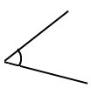 Identify the following types of angles drawn.

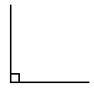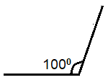a. b. c.

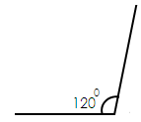

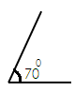d. e. f.

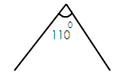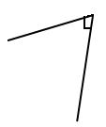g. h. i.

**CALCULATIONS ON ANGLES (FINDING UNKNOWN ANGLES)**

**A. Right angles.**

**NOTES:**

* Two or more angles that form a right angle are called **complementary angles**.
* Angles formed in a right angle give a sum of 900.

**Examples:**

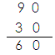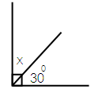 1. Find the value of X in degrees.

x _ 300 = 900

x + 300 – 300 = 900 -300

x = 60

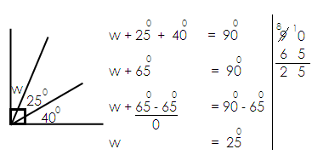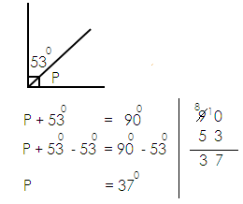 2. Find the value of P in degrees. 3. Work out the value for w.

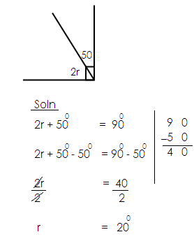 4. Work out the value for y.

**Activity:**

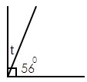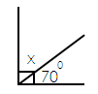1. Find the size of the angles marked with letters.

a. b.

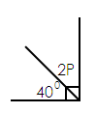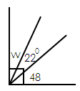

c. d.

e. Find the complement of 490.

F. Work out the complement of 770

**Straight angle.**

**Note:**

* Two or more angles that are formed on a straight angle/line are called **supplementary angles.**
* Angles formed on a straight angle/line give a sum of 1800.

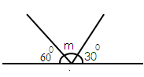 **Examples**:

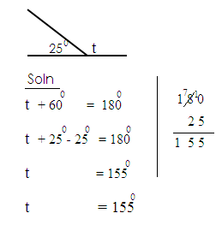 1. Find the size of t 2.

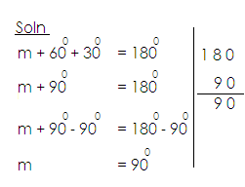

**Activity:**

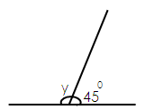 2. Find the size of the angles marked with letter.

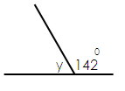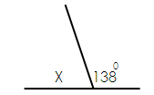 a. b. c.

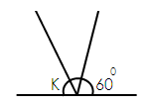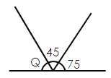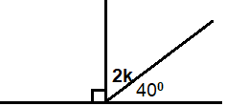 e. f.

d.

g. Calculate the supplement of 1490.

h. Find the supplement of 800.

**MEASURES:**

1. **Money**

* Recognition of money.
* Value of money.
* Operations on money.

- Addition

- Subtraction

- Multiplication

- Division

- Shopping list

- Shop Profit

- Finding profit

- Finding loss

2. **Time:**

(a) Days of the week

* Changing days to weeks.
* Changing weeks to days.
* Addition of Days and weeks.
* Subtraction of Days and weeks.

(b) Months of the year

* Changing of months and years.
* Changing years and months.
* Addition of years and months.
* Subtraction of years and months.

(c) Hours and days

* Changing days to hours.
* Changing hours to days.

(d) Hours and minutes

* Changing hours to minutes.
* Changing minutes to hours.
* Addition of hours and minutes.
* Subtract of hours and minutes.

**Telling time**

**Note**: A complete turn on the clock face is equal to 60minutes.

* Tell time using the minute hand and the hour hand.

**Telling time in hours**

* Telling time in minutes and hours using “past”.
* Telling time in minutes and hours using “to”.
* Writing time in digital form under “past”.
* Writing time in digital form under “to”
* Writing time in a.m. or p.m.

1. The time table

3. **LENGTH, MASS, CAPACITY**

**(a) LENGTH**

* Table of units
* Conversation of units

- Changing mm to cm

- changing cm to mm

- changing metres to cm

- changing cm to metres

- changing km to metres.

**FINDING DISTANCE**

* Finding perimeter of squares.
* Finding perimeter of rectangles
* Finding perimeter of triangles and other shapes.

**FINDING AREA**

* Finding area of squares.
* Finding area of rectangles.
* Finding area of triangles.

1. **MASS**

* Table of units
* Conversation of units
* Changing kilograms to grams
* Word problems on conversation of mass.
* Operation on mass.
* Addition of kilograms and grams.
* Word problems
* Subtraction of kilograms and grams.
* Word problems

1. **CAPACITY**

* Table of units
* Conversation of units of capacity.

- Changing cl to ml

- Changing ml to cl

- Changing litres to ml

- Changing ml to litres

- Addition of litres and ml.

- Half and quarter litres.

**ALGEBRA**

Forming expressions

* Involving addition
* Involving subtraction

**Solving equations**

Review without unknown

Involving unknown

* Addition
* Subtraction
* Multiplication
* Division

Forming and solving simple equations

* Involving addition
* Involving subtraction
* Multiplication
* Involving division

**MONEY**

* Money is a medium of exchange.

**Identification of coins and notes.**

**Coins**

* 50 shillings coin
* 100 shillings coin
* 200-shilling coin
* 500-shilling coin
* 1000-shilling coin

**NOTES:**

Notes are paper money

* 1000 shillings note
* 2000 shillings note
* 5000 shillings note
* 10,000-shilling note
* 20,000-shilling note
* 50,000 shillings note.

**Note:**

The currency used in Uganda is Uganda shillings.

**Finding values of money**

**Example**s

1. A boy had 2 coins of 100 shilling. How much money did he have altogether?

1 coin = sh. 100

2 coin = sh. 100

X 2

Sh. 200

2. John was given 4 one thousand shillings notes, how much money did he get altogether.

1 note = sh. 1000

4 notes = sh. 1000

x 4

Sh. 4000

A man received 2 coins of sh. 500 and 3 notes of sh. 2000. How much did he receive altogether?

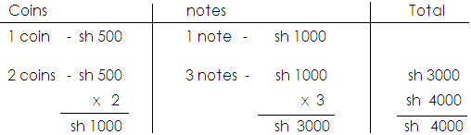

1. James was given 4 coins of sh. 200, how much money did he have altogether?

2. A boy received 4 notes of sh. 500. How much was it altogether?

3. Juma had 5 coins of sh. 200 and 2 notes of sh. 1000, how much did he have altogether.

4. If I have 5 notes of sh. 10,000, how much is this?

5. Namusoke received 8 coins of sh. 500 and 3 notes of sh. 1000. Find the total amount of money she received.

6. Tito withdraw 2 notes of sh. 5000 and 4 notes of sh. 2000 from the bank. How much did he withdraw altogether?

**OPERATION ON MONEY**

**Addition of money.**

**Examples**

Add: sh. 4000 + sh. 200

**Soln.**

Sh. 400

Sh. 200

**+ sh. 600**

Musa had sh. 480 and he was given sh. 560. How much did he have altogether?

**Soln.**

Sh. 480

Sh. 560

**Sh. 1040**

**Activity.**

Work out the following.

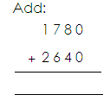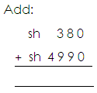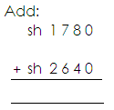

4. A porter earns sh. 1500 in the morning and sh.2700 in the afternoon. How much does the porter earn altogether?

5. John has sh.4500 and Mary has sh. 3750. How much money do the two children have altogether?

6. A mother bought meat at sh.25000 and a bunch of matooke for sh. 45500. How much did she spend altogether?

7. Alice’s school fees is sh. 7850 and Jane’s fees is sh. 1890. How much money do the two pupils pay altogether?

**Subtraction of money**

1. Work out: sh. 240 – sh. 130

**Soln.**

Sh. 240

_Sh. 130

Sh. 110

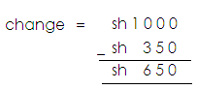2. Peter had sh. 1000, if he spent sh. 350. How much was his change?

**Activity:**

1. How much change do I get if I spend sh. 6500 from sh. 20,000?

2. Kato had sh. 5000 and he used sh. 2000. How much did he remain with?

3. Subtract sh. 6000 – sh. 3700.

4. Work out: sh. 5000 – sh. 2500.

5. Karenge had a one-thousand-shilling note and he spent sh. 450. What was his change?

6. Naigino had sh. 500, if she spends sh. 3750 on Vaseline, what is her change?

7. Agaba has sh. 10000 and he spent sh. 2500 on transport, what was his change?

**MULTIPLICATION OF MONEY.**

**Examples**

1. 1 book costs sh. 800, find the cost of 5 such similar book.

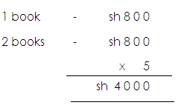 **Soln.**

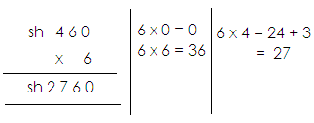

2. Multiply:

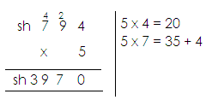

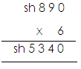3. Multiply: 4. Work out:

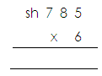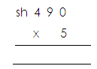**Activity:**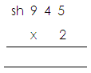 2. Work out**:** 3. Multiply:

1. Multiply:

4. One pen costs sh. 1500. How much will 6 pens cost?

5. Find the cost of 5 exercise books, if one book cots sh. 320.

6. The cost of 1 loaf of bread is sh. 1600. Find the cost of 3 loaves.

7. The cost of 1 book is sh. 370. Find the cost of 10 books.

**DIVISION OF MONEY.**

**Find unit cost**

**Examples**:

4 books cost sh. 2400. Find the cost of 1 book.

**Soln.**

4 books - sh. 2400

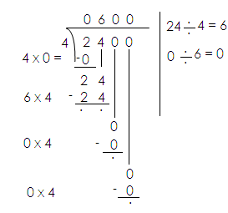1 book - sh. 2400 ÷ 4

Therefore: 1 book cost sh. 600

2. A trader sold 8 shirts at sh. 32000. How much did he sell each shirt?

**Soln.**

8 shirts - sh. 32000

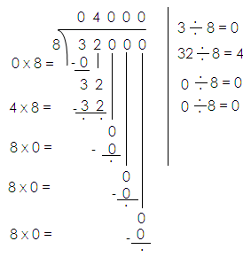 1 shirt - sh. 32000 ÷ 8

Therefore, 1 shirt costs sh. 4000.

**Activity:**

1. Divide sh. 840 among 4 girls.

2. A farmer sold 8 bags of coffee for sh. 40000, what was the price of one bag?

3. Akello gave sh. 1200 to her 3 children to share equally. How much did each child get?

4. A shopkeeper sold 4 loaves of bread. What was the cost of 1 loaf of bread?

5. Share sh.1400 among 7 people. How much money will each person get?

6. A school sh.12000 to share it among 6 workers, how much did each work get?

7. A milk man supplies 7 schools with 847 litres. How much milk does each school receive?

8. Divide sh. 240 by 8.

**SHOPPING LIST**

Below is a shopping list at item at Jovan’s shop. Use it to answer questions.

1 book costs - sh. 1000

1 pencil costs - sh. 200

1 set costs - sh. 1000

a. Find the cost of a set and a book.

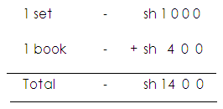 **Soln.**

b. If Okello bought 2 pencils and 3 books. How much money did he pay altogether?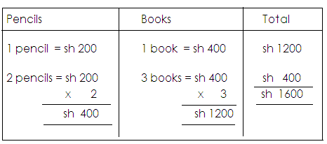

A man went to the market and bought the following items.

**Soln.**

2kg of sugar at sh. 4000 a kg.

3 bars of soap at sh. 2000 each bar.

1kg of rice at sh. 2000

a. How much did he pay for sugar?

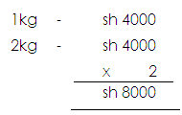 **Soln.**

1. How much did he spend on soap and rice altogether?

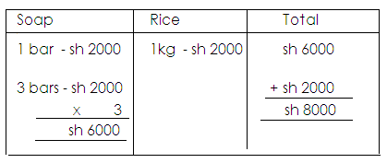**Soln.**

1. How much did he spend on all items?

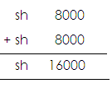**Soln.**

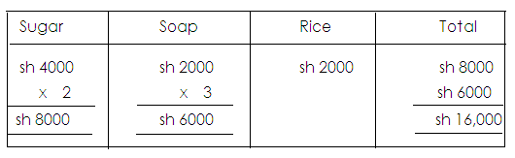**Or**

**Activity.**

1. Below is the cost of different items at the supermarket.

1 bar of soap costs sh. 3000

1kg of meat costs sh. 8000

1kg of rice costs sh. 4000

1. Find the cost of soap and 1kg of rice.
2. How much can a man spend on 2kg of meat and 3 bars of soap?

2. Okello bought the following items from the market.

- 2kg of beans at sh. 3000 a kg.

- 4 books at sh. 1000 each book.

- 1 mathematical set at sh. 2000.

a. How much did he spend on beans?

b. How much did he spend on books and a mathematical set?

c. Calculate his total expenditure.

**SHOPPING BILLS**

Vocabulary used

1. item

2. Quantity = Amount

Unit Cost

3. Unit Cost - Is the cost of each item.

Unit cost - Amount

Quantity

4. Total Cost - Quantity x unit cost

**Completing bill tables**

**Examples**

Complete the bill table below.

|  |  |  |  |
| --- | --- | --- | --- |
| **Item** | **Quantity** | **Unit cost** | **Amount** |
| Bread | 3 loaves | Sh. 2000 | _____________ |
| Beans | ____________ | Sh. 2400 | Sh. 24000 |
| Sugar | 4kg | _________ | Sh. 8000 |
| Rice | 2kg | Sh. 1200 | _____________ |
| **TOTAL EXPENDITURE** | | | ______________ |

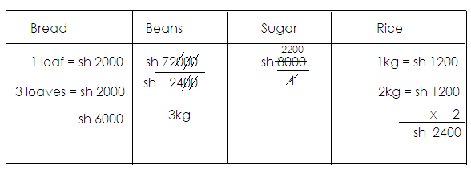

**Total**

Bread - sh. 6000

Beans - sh. 7200

Sugar - sh. 8000

Rice - sh. 2400

**Total sh. 23000**

**Activity:**

1(a) Complete the bill below.

|  |  |  |  |
| --- | --- | --- | --- |
| **Item** | **Quantity** | **Unit cost** | **Amount** |
| Beef | 3kg | Sh. 8000 | sh. __________ |
| Peas | _____kg | Sh. 4800 | sh. 9600 |
| Rice | 3kg | Sh. _________ | sh. 9000 |
| **Total expenditure** | | | sh. ___________ |

1. Work out the change if one had sh. 50,000.

2(a) Complete the bill table below showing A man’s expenditure.

|  |  |  |  |
| --- | --- | --- | --- |
| **Item** | **Quantity** | **Unit cost** | **Amount** |
| Onions | 3kg | sh. 2500 | sh. _______ |
| Salt | 2kg | sh. __________ | sh 6000 |
| Tomatoes | _______kg | sh. 600 | sh. 1200 |
| Cooking oil | 5kg | sh. 5500 | sh. ________ |
| **Total expenditure** | | | sh. ________ |

(b) Calculate his change if he had sh. 80000.

**PROFIT**

Profit is the amount gained after selling.

**Note:**

Profits is realized when the selling price is more than the cost price.

**Profit = Selling price – Buying price**

**FINDING PROFIT**

**Examples:**

1. A shopkeeper buys a book at sh. 2500 and sells it at sh. 3800. What profit does she get?

**Soln.**

Selling price - sh. 3800

Buying price - -sh. 2500

Profit sh. 1300

2. Abdul bought a shirt at sh. 800. He sold it at sh. 1000. What was his profit?

**Soln.**

Selling price - sh. 1000

Buying price - -sh. 800

Profit sh. 200

**Activity:**

1. Rita bought a radio at sh. 25,000, she later sold it at sh. 32,000. What was her profit?

2. Kato bought a pen at sh. 500 and sold it at sh. 700. What was his profit?

3. Napyo sold a book at sh. 900 which she had bought at sh. 750. What was her profit?

4. Ouma bought a packet of sugar at sh. 1500 and sold it at sh. 2000. What was his profit?

5. A lady sold a goat at sh. 7500 which she bought at sh. 5000. What profit did she make?

6. A shopkeeper bought a bag at sh. 13,00 and sold it at sh. 18,000. Find the profit?

7. The price of a dress was sh. 12,000. It was later sold at sh. 15000. What was the profit?

**LOSS**

Loss is the amount lost after selling.

**Note:**

Loss is realized when the buying price is more than the selling price.

Loss - Buying price – Selling price

**Examples:**

1. Omondi bought a book at sh. 1200 and sold it at sh. 800. What was his Loss?

**Soln.**

Buying price - sh. 1200

Selling price - sh. 800

Loss sh. 400

2. Ntanda bought a shirt at sh. 587500 and sold it at sh. 353500. What amount of money did he lose?

Buying price - sh. 587500

Selling price - sh. 353500

Loss sh. 234000

**Activity**:

1. Peter bought a watch at sh. 11000 and sold it at sh. 8000. What was his loss?

2. Babu bought a box of cakes at sh. 1500 and sold it at sh. 1200. What was his loss?

3. What was the loss on a commodity bought at sh. 2000 and sold at sh. 1700?

4. Annet bought a mathematical set at sh. 2800 and sold it at sh. 2200. What was the loss?

5. A box of Kimbo is bought at sh. 3500 and is sold at sh. 2900. What was her loss?

6. Musisi bought a tin of Panadol at sh. 12,000 and sold it at sh. 9500. What was his loss?

7. John sold a bottle of milk at sh. 1500 which he bought at sh. 1900. What was the loss?

**TIME.**

Is the quantity of the availability of duration.

**Days of the week**

1. Sunday 2. Monday 3. Tuesday 4. Wednesday

5. Thursday 6. Friday

|  |  |
| --- | --- |
| **Day** | **Position** |
| Sunday  Monday  Tuesday  Wednesday  Thursday  Friday  Saturday | 1st  2nd  3rd  4th  5th  6th  7th |

**CHANGING WEEKS TO DAYS**

Note:

A week is a period of 7 days.

1 week = 7 days

**Example**:

1. How many days are in 2 weeks.

**Soln.**

1 week = 7 days

2 weeks = (2 x2) days

= 14 days

2. Change 5 weeks into days

Soln.

1 week = 7 days

5 weeks = (5x7) days

= 35 days

3. Express 7 weeks into days

1 week = 7 days

5 weeks = (7 x7) days

= 49 days

**Activity:**

1. How many days are in 4 weeks?

2. How many days are in 6 weeks?

3. Change 11 weeks into days.

4. How many days are in the following weeks?

(a) 9 weeks (b) 3 weeks

(c) 8 weeks (d) 13 weeks

**CHANGING DAYS TO WEEKS**

Examples:

1. How many weeks are in 2 days?

**Soln.**

7 days = 1week

21 days = weeks

= 5 weeks

2. How many weeks are in 35 days?

**Soln.**

7 days = 1week

35 days = weeks

= 5 weeks

3. Change 24 days into weeks.

**Soln.**

7 days = 1week

14 days = weeks

= 2 weeks

**Activity:**

1. How many weeks are in 28 days?

2. How many weeks are in 42 days?

3. Express 49 days as weeks.

4. Change the following days into weeks.

(a) 56 days (b) 70 days

(c) 7 days (d) 84 days

**Addition of days and weeks**

**Note:**

* 1 week = 7 days
* We cannot have more than 6 days in column of days.

**Examples**:

Work out: **Weeks days wk d**

4 3 9 ÷ 7 = 1 rem 2

+ 1 6 write 1 day in days

6 2 take 2 weeks to weeks

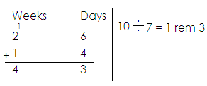

Add:

A carpenter took 5 weeks 5 days to make a wooden bed and 4 weeks 6 days to make a cupboard. How long did the carpenter take on both?

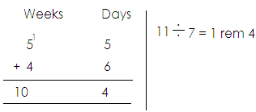

**Activity.**

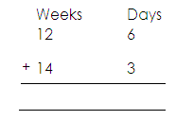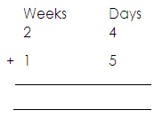Add the following

1. 2.

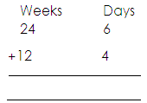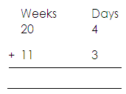 3. 4.

5. A farmer took 3 weeks to harvest her coffee and 4 weeks 5 days to dry it. What was the total number of weeks and days taken?

6. Mr. Kimuli spent 4 weeks 3 days fixing the root of his house and 1 week 5 days pointing it. How long did all this take?

7. A ship taken 5 weeks 2 days to soil from Mombasa to Kisumu and 3 weeks 6 days to Cape Town. How long does this journey take?

**Subtraction of weeks and days.**

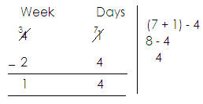 **Examples I**:

1. 2. **Examples II**

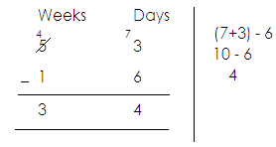 Work out:

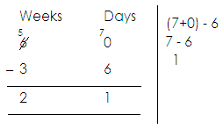3. **Example III**

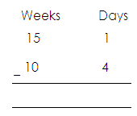**Activity:**

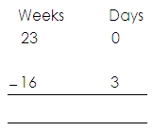1. Subtract: 2. 3.

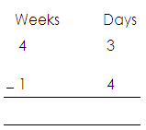

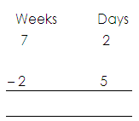4.

**MONTHS OF THE YEAR.**

There are 12 months in the year.

**Months** **Days.**

January 31

February 28 or 29

March 31

April 30

May 31

June 31

August 30

September 31

October 30

November 30

December. 31

**February has 28 days in an ordinary year and 29 days in a leap year.**

**Note.**

* An ordinary year is a year with 365
* An ordinary year gives a remainder when divided by 4
* A leap year is year with 366 days
* A leap year happens after every 4 years.
* A leap year does not give a remainder when divided by 4.

**Activity.**

1. How many days has the month of May?

2. How many months have 30 days?

3. Which name is given to a year that has 365 days?

4. Name the month of the years that has less than 30 days.

5. Which of these given years are leap years?

a)1995

b) 1971

c) 1969

e) 1981

f) 1994

g) 1992

**CHANGING YEARS TO MONTHS.**

**Examples**

1. How many months are in 2years?

I year= 12 months

2 years= (2x 12) months

= 24 months.

2. Change 7 years to months

1 year= 12 months

7 year= 7x 12 months

= 84months.

3. How many months are in a a year?

1 year = 12 months

= x **12** months

= 3months.

4.How many months are in

1 year = 12 months

1 = x 12 months

1 years = 18 months.

**Activity**

1. How many months are in 9 years

2. Alex went to Rwanda and stayed there for a year. How many months did he spend in Rwanda?

3. Change 2 years to months.

4. Express the following years in months

a)3 years

b) Year

c) 5

d)12 years.

**Changing months to years.**

12 months 1 year

**Examples**

1. Change 24 months to year.

**solution**

12 months 1 year

24 months= (24÷12) years

= 2years.

2. Find out the number of years that are in 30 months.

12 months = 1 year

30 months = 2 =

30 months =2 Years.

**Activity.**

Changing the following months to year.

a)12 months

b)36 months

c)18 months

d)48 months

c)60 months

d)42 months

g)24 months.

**Addition of year and months.**

**Note**

Don’t have more than 11 months in the column of months.

**Examples**

1. Add: years months

4 8

+1 2

5 10

2. Workout. Years months.

3 7 7 + 5 = 12

+4 5 12÷ 12= 1 year rem 0 months

8 0

3. Add. Years months

9 6

+3 8 14 ÷ 12= 1 rem 2

13 2

**Activity.**

Add the following years and months.

Years months

2 4

+1 5

___________________________

Years months.

4 7

+2 5

______________________________

Years months

2 7

+4 5

_________________________

**Add** years months

8 9

+5 4

________________________

Years months

12 7

+13 6

________________________

6.Years months.

14 9

20 8

__________________________

7. Years months

30 3

+20 7

_____________________________

**Subtraction of years and months.**

**Note**

When regrouping in subtraction of years and months, regroup 12

**Examples**

Subtract

Years months

9 8

3 5

______________________

Subtract

Years month 12 + 3=15

8 3 15-6 =9

-4 6

__________________________

Subtract

years months

7 2 12+2 =14

3 7 14- 7=7

3 7

**Activity**

**Subtract**

1. Years months.

6 4

- 2 3

2.Years months

8 6

4 7

____________________________

3.Years months

6 2

-3 7

4. Years months

17 3

-13 5

5.Years months.

8 8

- 3 9

_______________________________

6. years months.

14 3

-12 7

_____________________

**HOURS AND DAYS.**

**Changing days to hours.**

1 day = 24 hours

**Examples.**

How many hours are in 2 days?

**Solution**

1 day = 24 hours

2 days = (2x 24) hours

=48 hours.

Change 7 days to hours.

**solution**

1 day = 24 hours

7 days= 7 x 24) hours

= 2 4

x 7

1 6 8 hours

**Activity**

1.How many hours are in the following days.

a) 4 days

b) 6 days

c) 8 days

d) 5 days

2. Change the following days to hours.

a) 8 days

b) 4

c) 9 days.

**Changing hours to days.**

**Note:**

24 hours = l day

**Examples**

Change 48 hours to day

s**olution**

24 hours = l day

48 hours = 48 days

24

= 2 days.

Change 96 hours to days.

24 hours = 1 day

96 hours = 96

24 days

= 4 days.

**Activity**

1 change the following hours to days

a) 120 days

b) 168 hours

c) 72 days

d) 144 days

e) 24 hours

f) 192

**HOURS AND MINUTES.**

**Changing hours to minutes**

**Note:**

1 hour =60 minutes

**Examples**

Change 26 hours to minutes

Solution

1 hour = 60 minutes

2 hours= (2x 60) minutes

=120 minutes

Covert 2 hour to minutes

1 hour = 60 minutes

2 hours=(2 x 60) minutes

5 x 60) minutes

2

(5x 30) minutes

= 150 minutes

**Activity**

1. Change 3 hours to minutes

2. Change 1 hours to minutes

3. Change the following hours to minutes

a)4 hours

b) 6 hours

c) 10 hours

d) 3 hours.

e) 6 hours.

f) 9 hours.

**Changing minutes to hours**

**Note**:

60 minutes = 1hour

Examples

Change 120 minutes to hours

**solution**

60 minutes = 1hour

120 minutes =120

60

= 2 hours.

Express 180 minutes to hours

**Solution**

60 minutes = 1hour

180 minutes= 180

60

= 3 hours.

Covert 150 minutes into hours.

**Solution**

60 minutes = 1hour

150 minutes= 150

6

=2 hours.

**Activity**

1. Change 60 minutes to hours

2. Express 240 minutes to hours

3. Change 360 minutes to hours

4. Change 90 minutes to hours

5. Express 300 minutes to hours

6. Change 195 minutes to hours.

**ADDITION OF HOURS AND MINUTES**

**Note:**

Don’t have more than 59 minutes in the column of minutes

**Examples**

Add: HRS MIN

5 30

+6 20

11 50

Add: Hrs Min = 50 + 20= 70

10 50 = 70÷ 60

+12 20 1 rem 10

_______________________

Add: Hrs min 30+ 30

13 30 = 60

+12 30

**Activity**

**Add the following**

1.Hrs min 4) Hrs min

5 40 12 20

+ 3 10 +14 40

____________________ _____________

2. Hrs min 5) Add: Hrs min

9 30 16 50

+ 2 40 +13 40

______________________________ ___________________

3. Add: Hrs. min 6) Add: Hrs. min

10 50 16 54

+ 3 30 +12 24

_________________ __________________

7) Add: Hrs min

5 59

+4 49

______________________

8. Add 3 hours 35 minutes to 4 hours 42 minutes

9. Angela cooked beans for 3 hours 15 minutes and meat for 1 hour 45 minutes. How much time did she spend cooking?

**SUBTRACTION OF HOURS AND MINUTES.**

**Note**

When regrouping in subtraction of hours and minutes, regroup 1 hour = 60minutes

**Examples**

1.Subtract: Hrs. min

5 50

-2 30

__________________

2.Subtract: Hrs. min

6 10 60 + 10

- 3 50 70 - 50

2 20 = 20

3.Subtract: Hrs min

7 20 60+ 20

- 4 40

2 40 80- 40 = 40

**Activity.**

1. Workout the following.

Hrs min 3 Hrs min

8 30 14 15

-4 50 - 8 20

______________

2. Hrs min 4 Hrs min

1 6 01 18 30

- 5 50 - 5 40

_________________ _____________

5 Hrs min

16 30 6 Hrs min

-12 30 1 7 0 2

________________ 5 4 0

**TELLING TIME.**

**NOTE**

* A complete turn on the clock face is equal to 60 minutes.
* We tell time using two hands i.e. The minute hand and the hour hand.

**TELLING TIME IN HOURS.**

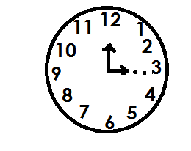Tell the time on the clock face below.

The time is 3 o’clock

Draw a clock face and on it show 7 o’clock

**Solution**

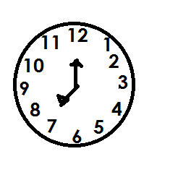

**Activity**

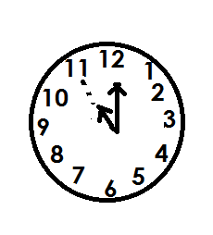1. Write the time shown on the clock face below.

a)

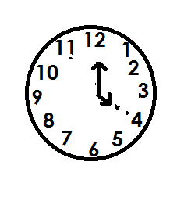b)

2. Draw clock face and show the time.

a) 9 o’clock

b) 2 o’clock

d) 6 0’clock

**TELLING TIME IN MINUTES AND HOURS USING “PAST”**

**NOTE**

When the minute hand is to the right of a clock face, the minutes are less than 30 and it is minutes past.

**Examples.**

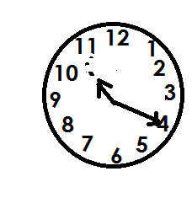1. Tell the time shown on the clock face below.

It is 20 minutes past 10

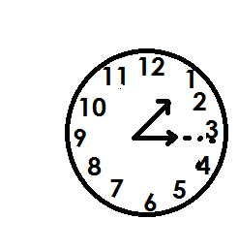2. What is the time?

The time is 5 minutes past 3

3. Draw a clock face and on it show 15 minutes past 8

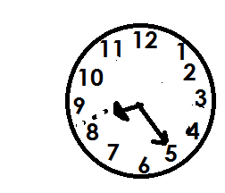**Solution**

**Activity**

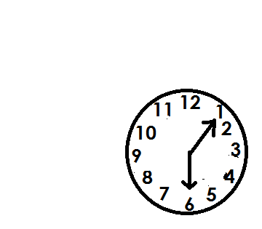Study the clock faces and write the time

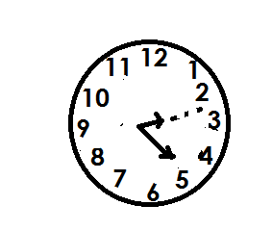a) c)

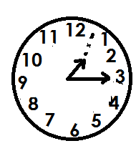 d)

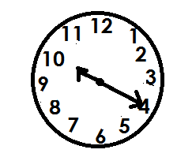b)

2. Draw clock faces and shows

a) 5 minutes past 12

b) 20 minutes past 9

c) 10 minutes past 6

c) 25 minutes past 11

**TELLING TIME IN MINUTES AND HOURS USING “TO”**

**Note:**

When the minute hand is to the left of a clock, minutes are more than 30 and its minutes to

**Examples**

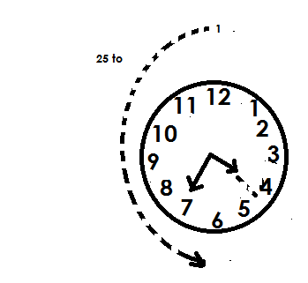1. What is the time shown on the clock face below?

The time is 25 minutes to 5

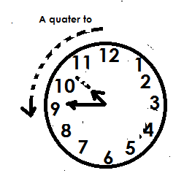2.Tell the time

**solution**

The time is quarter to 11

**Activity.**

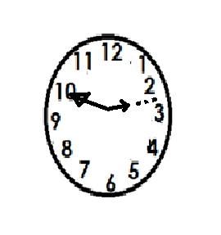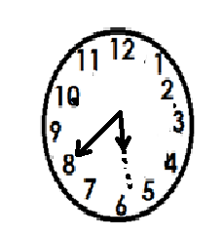Study the clock faces below and tell the time.

a) b)

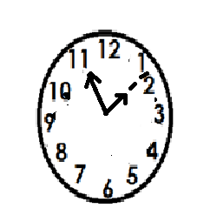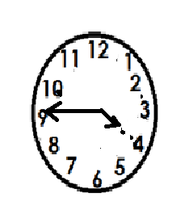c) d)

2. Draw clock faces and show the time

a) 25 minutes to 12

b) 10 minutes to 12

c) 30 minutes to 7

d) Quarter to 1

**WRITING TIME IN DIGITAL FORM**

**Examples.**

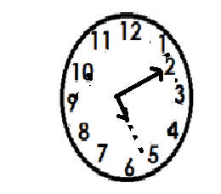1. Write the time in digital from shown on the clock face

5:10

Express the time in digital form

20 minutes past 8

**Solution**

8: 20

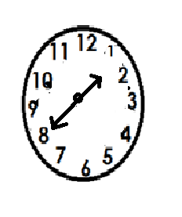2. Express the time shown on the clock face in digital form.

1: 40

Write the time in digital from

10 minutes to 4

**Solution**

Hrs min

4 00

- 10

3 : 50

60- 10 = 50

The time is 3 : 50

**Activity**

1. Write the time on the clock faces below in digital form.

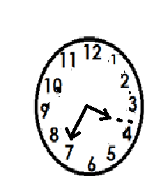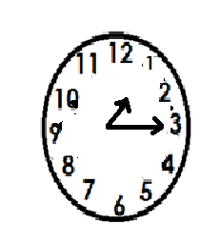a) b)

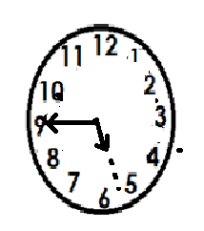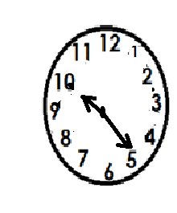c) c)

2. Write the following time in digital form.

a) 10 minutes past 9

b) Quarter past 10

c) 15 minutes to 4

d) 25 minutes to 1

**TIME IN AM OR PM**

am means Ante meridiem

am is the first part of the day hence morning time

am starts from 12:00 midnight to 12:00 midday

pm means post mid night

pm is the second part of the day hence afternoon or evening time.

**Examples**

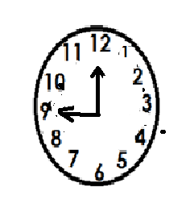1. Write the time shown on the clock face below in am and pm

**Solution**

9:00 am

9:00pm

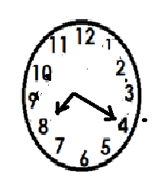2. Write the morning time on the clock face below

**Solution**

8: 20 am

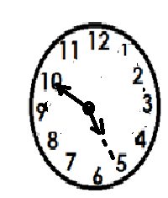3. Write the morning time shown on the clock below

**Solution**

5: 50 pm

4. Express 6 o’clock in the morning

**Solution**

6:00am

5. Write 8 o’clock in the afternoon

**Solution**

8:00pm

**Activity**

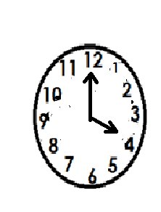1. Write the morning time shown on the clock face

2. Write the evening time shown on the clock face

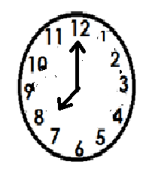

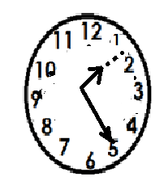3. Write the morning time on the clock face

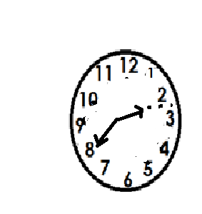4. Write the afternoon time shown on the clock face

5. Write the following time using am or pm

a) The time when the first lesson begins at 8: o’clock

b) The time when you go to sleep at 8o’clcok

c) The time when we go home a t quarter past 5 o’clock

d) What time is half past 3 o’clock in the afternoon?

3) The time when we go to school ate half past 7 o’clock in the morning.

**THE CALENDER.**

**Examples**

Study the calendar below and answer the questions that follow.

|  |  |  |  |  |  |  |
| --- | --- | --- | --- | --- | --- | --- |
| **JANUARY** | | | | | | |
| **SUN** | **MON** | **TUE** | **WED** | **THUR** | **FRI** | **SAT** |
|  |  |  | 1 | 2 | 3 | 4 |
| 5 | 6 | 7 | 8 | 9 | 10 | 11 |
| 12 | 13 | 14 | 15 | 16 | 17 | 18 |
| 19 | 20 | 21 | 22 | 23 | 24 | 25 |
| 26 | 27 | 28 | 29 | 30 | 31 |  |

1.On which day did the month begin?

**Solution**

On Wednesday

2. On which day did the month end?

**solution**

The month ended on Friday

3. Which day is the 14th of this month?

Tuesday

**Activity**

1. Study the calendar below and answer the questions that follow.

|  |  |  |  |  |  |  |
| --- | --- | --- | --- | --- | --- | --- |
| **SEPTEMBER** | | | | | | |
| **SUN** | **MON** | **TUE** | **WED** | **THUR** | **FRI** | **SAT** |
|  |  |  |  |  |  | 1 |
| 2 | 3 | 4 | 5 | 6 | 7 | 8 |
| 9 | 10 | 11 | 12 | 13 | 14 | 15 |
| 16 | 17 | 18 | 19 | 20 | 21 | 22 |
| 23 | 24 | 25 | 26 | 27 | 28 | 29 |
| 30 |  |  |  |  |  |  |

a) Which day month of this year is shown on the calendar?

b) How many days’ des the month have?

c) How many Fridays are there?

d) On which day did the month begin?

e) Which day is she 21st of this month?

2. Below is a calendar. Use it to answer questions that follow.

|  |  |  |  |  |  |  |
| --- | --- | --- | --- | --- | --- | --- |
| **FEBRUARY** | | | | | | |
| SUN | MON | TUE | WED | THUR | FRI | SAT |
|  |  | 1 | 2 | 3 | 4 | 5 |
| 6 | 7 | 8 | 9 | 10 | 11 | 12 |
| 13 | 14 | 15 | 16 | 17 | 18 | 19 |
| 20 | 21 | 22 | 23 | 24 | 25 | 26 |
| 27 | 28 |  |  |  |  |  |

a) Which day did the month start?

b) How many Thursday are in this month?

c) How many weekends are in this month?

d) Tony’s birthday will be on the first Saturday of this month. What will be the date?

**THE TIMETABLE.**

Use the timetable below to answer questions that follow.

|  |  |  |  |  |  |  |  |  |
| --- | --- | --- | --- | --- | --- | --- | --- | --- |
|  | **8:00am**  **9:00am** | **9:00am**  **10:30am** | **10:30am**  **11:00am** | **11:00am**  **12:00** | **12:00**  **1:00pm** | **1:00pm**  **2:00pm** | **2:00pm**  **3:00pm** | **3:00pm**  **4:00pm** |
| **MON** | MTC | ENG | **B** | MTC | SCI | **L** | SST | R. E |
| **TUE** | SST | MTC | **R** | ENG | SST | **U** | SCI | SCIE |
| **WED** | ENG | SST | **E** | MTC | RE | **N** | SCI | ENG |
| **THUR** | MTC | P. E | **A** | ENG | MTC | **C** | SST | SCIE |
| **FRI** | SCI | MTC | **K** | MUSIC | FAITH | **H** | ENG | SST |

**Example**

a. At what time is science lesson taught on Monday?

**solution**

At 12:00 noon

b) How many English lessons, start on Monday?

d) How many R.E lessons are taught for the whole week?

e) How many science lessons are taught in the afternoon for the whole week?

f) Which day of the week is P.E conducted

g) At what time does lunch time end?

**FINDING DURATION**

Duration is time used or taken

Duration= Ending time- starting time

D = ET - ST

**Examples**

Find the number of hours from 8:00am to 11:00am

**Solution**

Duration = ET - ST

Hrs. min

11 00

+ 8 00

3 00

There are 3 hours

A clan meeting started at 1:00pm and ended at 5:40pm. For how long was the meeting?

**Solution**

Duration = ET-ST

Hrs min

5 40

-1 00

4 40

It was for 4 hours 40 mins.

A bus left Kampala at 7:15 am and reached Jinja at 10:10 am. For how long was the whole journey

**Solution**

**Duration** = ET ST

Hrs. Min (60 + 10)- 15

10 10 70 -15

- 7 15 55

2 55

It was for 2 hours 55 minutes

**Activity**

1. A party started at 8:00am and ended at 10:30 am find the time taken.

2. A man reported on duty at 9: 00am and left at 11:00am, for how many hours was he at work?

3. A motorist started a journey at 1:00pm. If he reached his destination at 3:30pm. For how long was his journey?

4. A mathematical lesson started at 9:50 am and ended at 10:30 am. For how long was the lesson.

5. Matama started digging at 8:45am and stopped at 10:15 am. What time did she take?

6. A baby went to bed at 2:56pm. If she woke up at 4:10pm. for how long was she in bed?

7. How many hours are there between 7:00pm and 12:00midnight?

**LENGTH, MASS, CAPACITY.**

**LENGTH.**

Length is the distance of something from one end to the other.

**Table of units.**

Km ______ kilometer

Hm______ hectometers

Dm______ Decameters

M________ Meters

Dm_______ decimeter

cm_______ centimeters

mm______ millimeters

**Aid to memory**

kilo _______ King

Hecto ______ Henry’s

Deca ______ daughter

Meter ______ Mary

Deci ________ drank

Cent ________ cold

Milli _________ milk

**Changing cm to mm**

km hm Dm M dm cm mm

1 0

**Examples**

1. Covert 7cm to cm

**Solution**

1 cm= 10mm

7cm= 7x 10mm

= 70mm

2. Convert 60 cm to mm

**Solution**

1cm = 10mm

60cm = 60x 10mm

= 600mm

**Activity**

1. Convert the following centimeters to millimeters

a) 5cm f) 25cm

b) 4cm g) 15cm

d)40cm h) 80cm

e)100cm

**Changing mm to cm**

**Examples**

1. Change 100mm to cm

**Solution**

10 mm = 1cm

100mm= 100

10

= 10cm

2. Change 70 mm to cm

**Solution**

10 mm= 1cm

70 mm= 70

10

= 7cm

**Activity**

1**. Change the following mm to cm**

a) 300mm c) 80mm e) 150 mm

b) 50mm d) 90mm f) 200mm

**METRES AND CENTIMETERS.**

Changing M to cm

km Hm Dm M dm Cm mm

1 0 0

**Note:**

1m = 100 cm

**Examples**

1. Convert 6m to cm

**solution**

1 m= 100 cm

6m= 6x 100cm

= 600cm

2.covert 70m to cm

**solution**

1m =100cm

70 = 7x 100cm

= 700cm

3. Convert 0.5 m to cm

**Solution**

1 m = 100cm

0.5 m= 5 x 100cm

10

= 5x 10 cm

= 50cm

4. Convert 0.8 m to cm

**Solution**

1m = 100cm

0.8 m = 8 x100cm

10

= 8x 10 cm

= 80cm

**Activity**

1. Convert 80m to cm

2. Express 10m to cm

3. Convert 0.9m to cm

4. Convert 0.4 m to cm

5. Change the following meters to centimeters

a) 1.5m

b) 100m

c) 0.3m

**Changing cm to M**

**Examples**

1. Convert 100cm to m

**solution**

100cm = 1m

100cm = 100

100

=1m

2. Change 1200cm to m

**solution**

100cm = 1 m

1200cm = 1200

100

=12m

3. Convert 1300cm

**solution**

100cm= 13000

100

= 130m

**Activity**

1. Convert 1400cm to m

2. Express 1000cm to m

3. Change the following cm to meters

a1500cm

b.2000cm

c.1700cm

d.1800cm

**KILOMETERS AND METERS.**

1 KM = 1000CM

**Examples.**

1. Convert 7 km to m

**Solution**

1 km = 100m

7 km = 7x 100m

= 7000m

2. Anthony covered a distance of 60km from to home to school. Express the distance he covered in meters.

**solution**

1 km = 100m

60km=60 x 100m

= 60,000m

3. The distance from home to market is 8km.Express that distance in meters

**Solution**

1 km= 100m

8km= 8 x 100m

= 8000m

**Activity**

1. **Convert the following km to meters.**

a) 6 km

b.30 km

c. 0.5 km

d. 10km

2. 1 moved 12 km from Kajjansi to Kampala. Find the distance l covered in metres

3. Chris traveled a distance of 40km from his home to the mother’s home. Calculate the distance he covered in meters.

**PERIMETER.**

Perimeter is the total distance round a figure.

A figure is a closed sided shape.

**Examples of figures**

* Triangle
* square
* Rectangle
* Trapezium
* other polygons

**Finding perimeter of square**

**Examples**

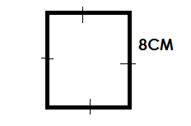**Find the perimeter of the figure below.**

Perimeter = s + s + s + s

= 8cm + 8cm + 8 cm + 8cm

= 32cm

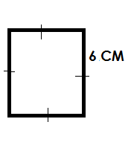**Find perimeter of a square whose side measures 6cm**

P = s + s + s + s

=6cm + 6cm + 6cm + 6cm

= 24cm

**Activity**

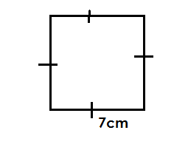Find the perimeter of the following figures

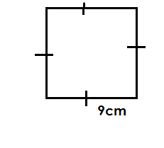a) b)

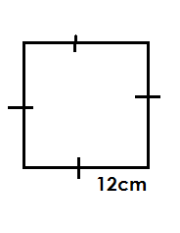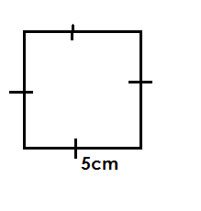

c) d)

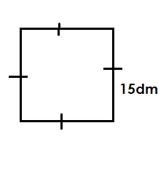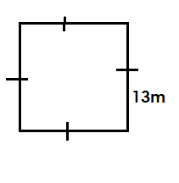

e) f)

2. Find the perimeter of a squares whose side measures 16cm

3. Calculate the perimeter of a square whose measures 20dm

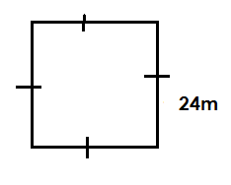4. Below a square garden

Calculate is perimeter

**Finding perimeter of a triangle**.

**Examples**

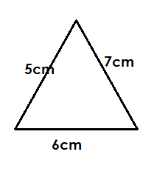1. Find the perimeter of the figure below.

**Solution**

P = s + s + s

=6cm + 7cm + 5cm

=18cm

Below is triangle.

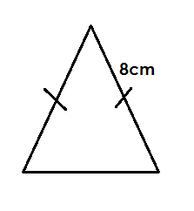

Calculate its perimeter.

**Solution**

P = s + s + s

=12dm + 10dm + 10dm

=32dm

**Activity.**

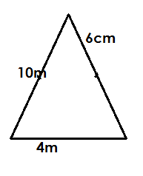Calculate the perimeter of the triangle below.

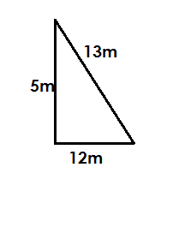a) b)

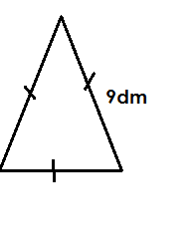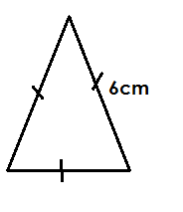

c) d)

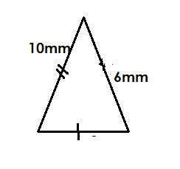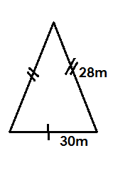

e) f)

2. Find the distance round an equilateral triangle with side 30m

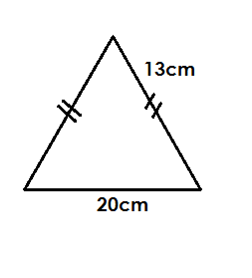3. Calculate perimeter of the figure below.

**Finding perimeter of other figures**

**Examples.**

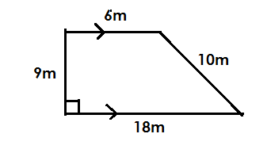Find the perimeter of the following figures.

P = s + s + s + s

= 18+ 9m+6m+10m

=48m

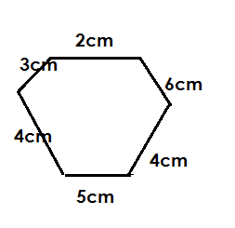Calculate the total distance round the figure below.

**solution**

P = s + s + s + s + s + s

= 4cm+5cm+4cm+6cm+2cm+3cm

= 24cm

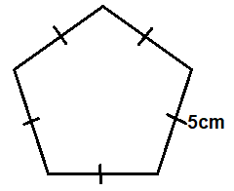Find perimeter of the pentagon below

p=s+s+S+S+S+s+S+S+

P = s + s + s + s + s

= 5dm + 5dm + 5dm + 5dm + 5dm

=25dm

**ACTIVITY**

Find perimeter of the following figure

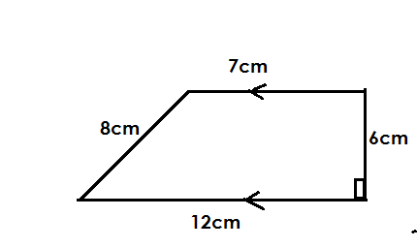1.

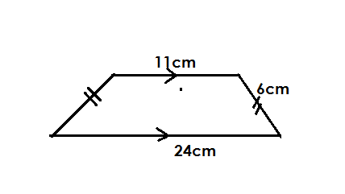2.

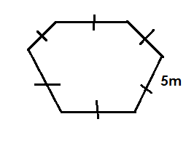

3

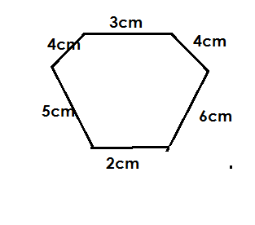

4.

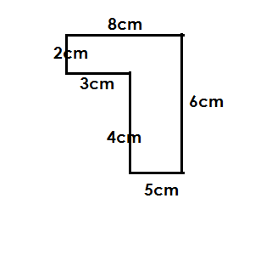

5.

**Finding perimeter of a rectangle.**

**Note:**

Two opposites sides of a rectangle are equal

**Examples**

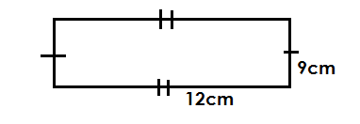Below is a rectangle. Find its perimeter.

P = L+W+L+W

= 12CM+9CM+12CM+9CM

=42CM

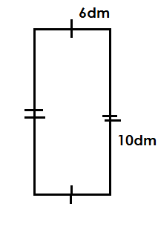Calculate the distance round the figure

Perimeter = L + W + L + W

=10dm+6dm+10dm+6dm

=32dm

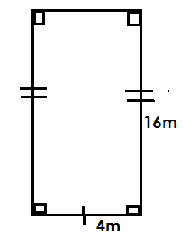**ACTIVITY**

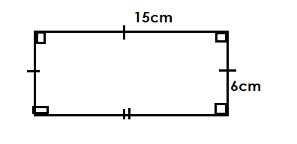 Calculate perimeter of the following figures

a) b)

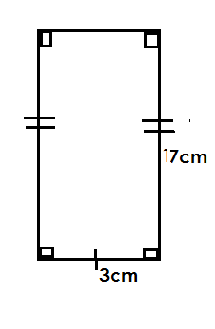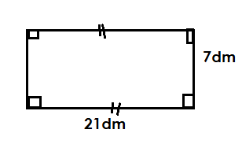c) d)

2. Calculate perimeter of a rectangular whose length is 24m and with 10m

3. Find the distance round a rectangle with length and width as 18dm and 12 dm respectively.

4. Calculate perimeter of a rectangle measuring 26cm by 12cm

**AREA**

Area is the space occupied by an object on a flat surface

Area is measured in square units

**Finding the area of a square below**

**Examples.**

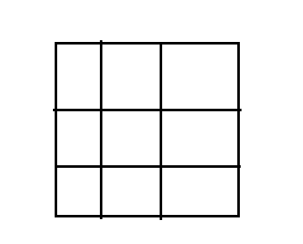Find the area of the figure below.

**solution**

By counting the number of squares

Area= 9 square units

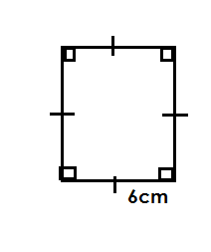Calculate area of the square below.

Area = side x side

= s x s

= 6cm x 6cm

=36cm**2**

**Activity**

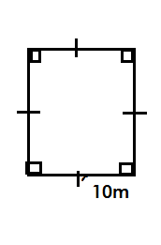Calculate the area of the figure below.

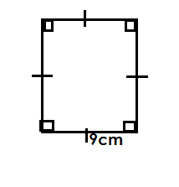1) 2)

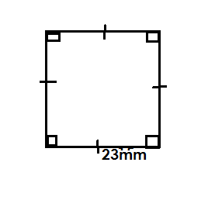

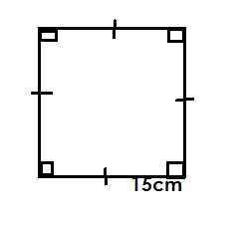3) 4)

6. Calculate the area of square whose side measure s7m

7. Find area of a rectangular garden with length of each side 11 hm

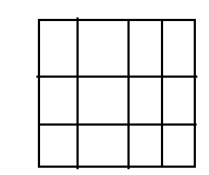8. Calculate area of the square below.

**Finding area of a rectangle.**

**Examples**

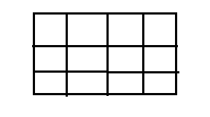Find the area of the figure below

By counting the number of squares.

Area= 12 square units

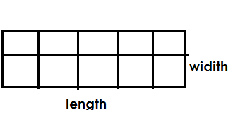Find area of the figure below

Area = length x width

= 5 sq x 2 sq

=10 square units.

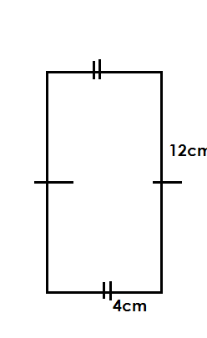Calculate area of the figure below

Area=Lx w

=12 cm x 4cm

=48cm**2**

**Activity**

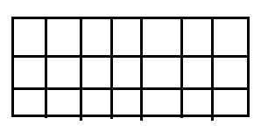Calculate area of the following figures

1.

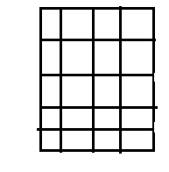

2.

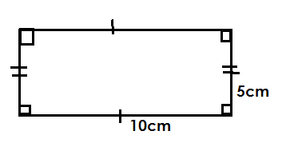

3.

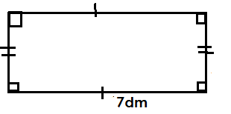

4.

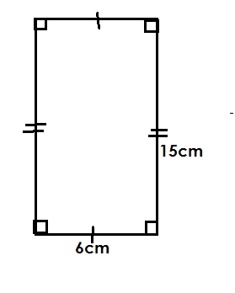

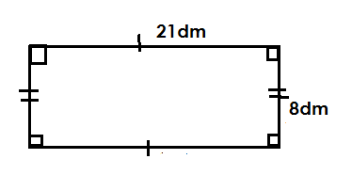 6)

5.

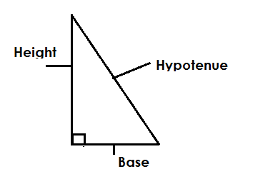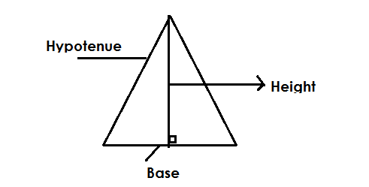**Finding area of a triangle**

**Note**

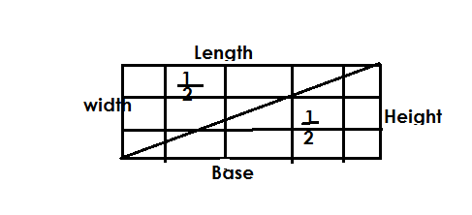Height is a line landing on the base at an angle of 90

Area of triangle is of the area of a rectangle.

A= x L x W

= x b x h

**Examples**

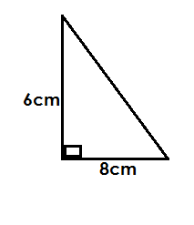Find the area of the triangle below.

**Solution**

Base = 8cm

Height= 6cm

Area= x bx h

= x 8 x 6

= 4cm x 6cm

= 24cm**2**

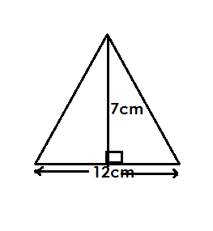Find the area of the figure below.

Area = x bx h

= 1 x 12 x 7cm

2

= 6cm x 7cm

= 42cm

**Activity**

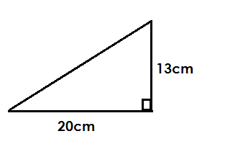Find the area of the following triangles

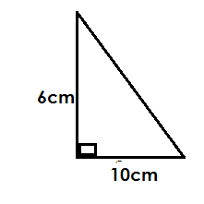a) b)

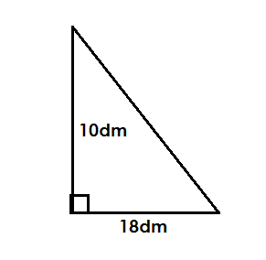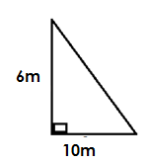3) 4)

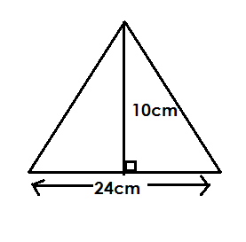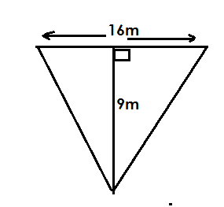

5) 6)

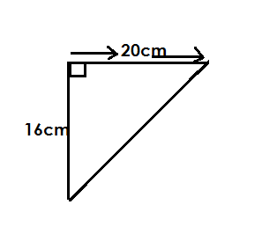

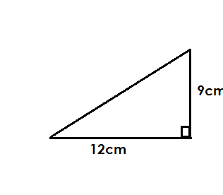7

**MASS.**

Mass is the weight of something

**Conversation units.**

Kilograms _________ kg

Hectogram ________ Hg

Decagram __________Dg

Gram ___________G

Decigram ________ Dg

Centigram ____________ cg

Milligram _____________ mg

**Aid to memory**

Kilo ___________ King

Hecto ____________ Henry’s

Deca ________ daughter

Gram ___________ Grace

Deci _______ drank

Cent _________ cold

Milli __________ milk

**Changing kilograms to grams.**

|  |  |  |  |  |  |  |
| --- | --- | --- | --- | --- | --- | --- |
| kg | Hg | Dg | g | Dg | cg | mg |
| 1 | 0 | 0 | 0 |  |  |  |

I kg = 1000g

**Examples**

Change 8kg to g

**Solution**

1 kg=1000g

8kg=8x 100g

=8000g

Change kg to g

**Solution**

1 kg=1000g

1 x 1000g

5

=200g

Express 2 kg as grams

**Solution**

1 kg = 1000g

= 2 x 1000g

= 5 x 500g

= 2500g

Convert 0.9 kg into g

**Solution**

l kg = 1000g

0.9 kg =0/9x 1000g

9 x 100g

= 900g

**Activity**

1. Change the following into grams

a) 4kg

b)12kg

c)23kg

2. Express the following as grams

a) 1

*2*

b)2

5

c) 1

4

3. Convert the following to grams

a) 3 kg

b) 5 kg

c) 11 kg

4. Change the following to grams

a) 0.4kg

b) 2.5 kg

c) 5.4kg

**Changing grams to kilograms.**

|  |  |  |  |  |  |  |
| --- | --- | --- | --- | --- | --- | --- |
| kg | Hg | Dg | g | dg | cg | mg |
| 1 | 0 | 0 | 0 |  |  |  |

1000g=1kg

**Examples**

Change = 6000g to kg

Solution

1000g=1kg

**=**

= 6kg

Change 200g into kg

s**olution**

1000g = 1kg

0.2

10

= 0.2 kg

Convert 580 g into kg

**solution**

1000g = 1kg

580g = 0.580

1000

= 0.58kg

**Activity**

**Change the following into kilograms**

a) 2000g

b) 13000g

c) 100g

d) 320g

e) 700g

f) 28500g

g) 3628g

**ADDITION OF KILOGRAMS AND GRAMS.**

**Examples**

Add: 5kg 200g + 2kg 700g

**solution**

kg g

5 200

+2 700

_____________________

Add: kg g

3 650

+4 550

8 200

Paul weighs 36kg 560g and peter weighs.48 kg 720g

Find their totals weight

Solution

kg g

36 560

+48 720

85 280

**Activity**

1. Add: 9 kg 320 g + 4 kg 280

2. Add: 23 kg 600g + 18 kg 400g

3. Add: kg g

6 800

+5 100

________________________

4. Add: kg g

55 648

+61 552

________________

5. Add kg g

17 300

+13 100

____________________

6. Alex weighs 28 kg 632g and Allan weighs 38kg 400g.Find their total weight.

7. Find the sum of 246kg 180 g and 102kg 200g

**SUBTRACTION OF KILOGRAMS AND GRAMS.**

**Examples**

1. Subtract: kg g

7 820

-5 600

2 220

2. Workout kg g

12 400

-8 850

3 550

3. Kato had 40kg 350g of salt. He sold 26kg 850 g of it. How much salt did he remain with?

**Solution**

kg g

40 1350

-26 850

13 500

**CAPACITY**

Is the amount of contact that a given container can hold.

**Conversation units**

Kilolitre - Kl

Hectoliter - Hl

Deciliter - Dl

Liter -L

Deciliter - dl

Centimeter - cl

Milliliter - ml

**Aid to memory.**

Kilo - king

Hecto - henry’s

Deca - daughter

Liter - Lydia

Deci - drank

Centi - cold

Milli - milk

**Changing centimeters to millitres.**

|  |  |  |  |  |  |  |
| --- | --- | --- | --- | --- | --- | --- |
| kl | Hl | Dl | l | dl | cl | ml |
|  |  |  |  |  | 1 | 0 |

I cl = 10ml

E**xamples**

Change 4cl to ml

**Solution**

1cl= 10ml

4cl= 4x 10ml

= 40ml

Change cl to ml

**solution**

1cl = 10ml

3cl = 3x 10m

5 5

= 3 x 2ml

= 6ml

Convert 4 cl into ml

**Solution**

1 cl = 10ml

4 x 10ml

= 9x 5

= 45ml

Change 0.8 cl to ml.

**Solution**

1 cl = 10ml

0.8cl = 0.8 X 10ml

= 8ml

**Activity**

Change the following into milliters

a) 680cl c) 4 cl

b)1 cl 5

2

f) 5

g) 0.4 cl

h) 0.35cl

**Changing millitres centimeters**

|  |  |  |  |  |  |  |
| --- | --- | --- | --- | --- | --- | --- |
| **kl** | **Hl** | **Dl** | **L** | **dl** | **Cl** | **Ml** |
|  |  |  |  |  | l | o |

10ml = 1cl

**Examples**

1. Change 120ml to cl

**Solution**

10ml = 1cl

120ml= 120

10

= 12cl

2. Convert 8ml into cl

**Solution**

10ml = 1cl

8ml= 0.8

10 cl

= 0.8 cl

3. Change 2ml to cl

**Solution**

10ml=1cl

2ml= 0.2

10

=0.2cl

**Activit**y

Change the following to centimeters

a) 180ml

b) 10ml

c) 0.7ml

d) 0.3ml

e) 78ml

f) 145ml

g) 3948ml

**Changing liters to milliters**

|  |  |  |  |  |  |  |
| --- | --- | --- | --- | --- | --- | --- |
| kl | Hl | Dl | l | dl | Cl | ml |
|  |  |  | 1 | 0 | 0 | 0 |

llitre = 1000l

**Examples**

Change 49l to ml

**Solution**

l l=10000ml

491=49x 1000ml

49000ml

Convert L into ML

**Solution.**

1 L= 1000ML

1L = 1 X 1000ML

5 5

= 200ML

Express 3 l as ml

**Solution**

1L=1000ML

3X 1000ml

7x 599ml

3500ml

Change 2,5l to ml

**Solution**

l l = 1000ml

2.5l = 25 x 1000ml

10

= 25 x 100

= 2500ml

**Activity**

Change the following into milliliters

a) 5l H) 0.6L

b) 27l I) 1.2L

c) 123l J) 4.5L

d) 1L

2

e) 2

g) 111L

2

**Changing millitres to liters**

|  |  |  |  |  |  |  |
| --- | --- | --- | --- | --- | --- | --- |
| **kl** | **Hl** | **Dl** | **l** | **dl** | **cl** | **ml** |
|  |  |  | **1** | **0** | **0** | **0** |

Therefore 1000ml -1L

**Examples**

Change 2300ml to liters.

**Solution**

1000ML=1L

23000ML= 23000

1000

= 23L

Change 750 ml to liters

**Solution**

1000ml= 1l

750ml= 0.750

1000

=0.75l

Convert 65 ml to liters

**Solution**

1000ml= 1l

65ml=0.065

1000

= 0.065L

**Activity**

Change the following to liters

a) 21000m

b) 2899ml

c)189ml

d)25ml

e) 45ml

f) 1080ml

g) 1002ml

**HALF AND QUARTER LITRES IN LITRES.**

**Note**

* l litre = 2half liters
* 1 liter= 4 quarter litre
* The denominator in fraction determines the number of parts in a whole

**Examples**

How many liters are in 2 liters?

**Solution**

1L = 2 half liters

2liters= (2X2) Half liters

= 4 half liters.

How many litre cups are in 5 lite jerry cans?

**Solution**

1 l= 4 quarter liter cups

5l= 5 x 4 quarter liter cups

= 20 quarter liter cups

**Activity**

1. How many liter bottles are in 4 litres?

2. How many litre bottles are in 4 liters?

3. Namuddu has 6 liters. How many liters has she got?

4. Divide 4 liters of milk into litres? How a many half liter will you get?

5. Opio has 3 litres of milk. He gaves lite of milk to each child. How many children does he give the milk?

**ALGEBRA**

Algebra is a branch of mathematics where symbols or letters represent quantities.

**Forming expressions and phrases**

**a) Forming expressions from Algebra**

**Examples**

1. n-5

Subtract 5 from n

2. 5n

Multiply 5 and n

= 12

Y divided by 3 the result is 12.

4. Multiply 3 by n and add 5 is the result

3 times n plus 5

**Activity**

Form algebraic phrases from the following algebraic expressions.

a) x t y

b) p- 8

c)

d) 3n + 5

e) 4n

f) 7m- 5

g) m = 5

3

**b) Forming algebraic expressions from phrases**

1.The product of p and r

p x r or pr

2. Add 5 to x

x t 5

3. 4 more than p

p x 4

**Activity**

1. Add 6 to n

2. Subtract 11 from m

3. Add Y and 6 the result is 10

4. p divide by 4 the result is 12

5. Subtract 6 from the product of y and 2

6. The result of the product of hand 2 is 8

7.13 is more than d

8. 4 is less than q.

**COLLECTING LIKE TERMS**

**Examples**

1. Simplify: 2pens + 3pens

Represent each pen with p

2p + 3p

5p

2. Collect like terms

3pencils + 4pencils + 6pencils

Represent each pencil with p

3p + 4p+6p

13p.

3. Simplify 7w + 8w+w

**Solution**

16w

**Activity.**

1. **Workout algebraically**

a) 9 cats + 7 cats

b) 15 frogs- 9 frogs

c) 12 pots + 3 pots+6pots

d) 5 eggs+4eggs+2eggs

e) 17cows-8cows

2. Simplify

a) 2p + 4p

b) 9a + 8a

c) 20d+11d

d) 11p + 7p

e) 7k+3k+5k

**More on collecting like terms**

**Examples**

1. Collect like terms

a+ b + a + b

a + a + b + a

2b + 2b

2.Simplify

r + p + 2r + p

r + 2r + p + p + 3r + 2p

3. Simplify:4k-2k

**Solution**

4k - 2k

2k

**4.** Simplify:7p - 3p + 4q

**solution**

7p - 3p + 4q

4p + 4q

**Activity**

**Simplify the following**

1. a + a + n + n

2. b + c + b + b

3. 9c + 8c + 2p + p

4. 4z + 8y + 2z + 3y

5. 7k - 2k

6. 24r - 20r

7. 4p – p + r

8. 4w + w - 2p

**SUBSTITUTION**

**Note**

**To substitute is to replace.**

**Examples**

1. If h = 2

Find the value of h+7

**Solution**

= h + 7

= 2 + 7

= 9

2. Given that a= 4, b= 3 and c=2.Find the values of

a) a + b + c

= 4 + 3 + 2

= 9

b) a + b - c

= (4 + 3) - 2

= 7 - 2

= 5

c) a - b

= 4 - 3

= 1

3. Given that m=6 and n= 3

a) 2m

**Solution**

= 2m

= 2 x m

= 2x 6

= 12

b) mn

= m x n

= 6 x 3

= 18

c) m

n

**solution**

m

n

= m ÷ n

= 6 ÷ 3

= 2

d) m

2

**Solution**

m

2

= m ÷ 2

= 6 ÷ 2

= 3

**Activity**

1.If a = 12, find the values of a + a + a + a

2.if y=6, find the value of y + 4

3.if m= 10, find the value of m - 7

a) 2m

b)

5. Given that r = 5, p = 4 and q = 3

Find

a) r + p + q

b) r - q

c) r + q - p

6. Given that k= 4 and m= 12

**Find**

a) 2k

b) km

c) m

k

d) 2m

k

**Solving simple Equations.**

**Examples**

a) Find the missing number in addition.

+ 4 = 7

**Solution**

+ 4-4 = 7-4

= 3

**Solve for the missing numbers**

5+ = 12

**solution**

5+ = 12

5- 5 + =12-5

= 7

**3. Solve for y**

y + 7 = 15

y + 7-7= 15-7

y= 8

4. Solve: 4+ n= 11

4- 4+ n= 11- 4

n = 7

**Activity**

**Solve for the following**

a) + 8 = 10

b) + 5= 12

c) 9+ = 20

d) 11+ = 25

e) m + 8 = 15

f) 17 + r= 30

g) y + 7= 18

**Solving simple equations**

**Involving subtraction**

**Examples.**

1. Find the missing number

- 8 = 12

- 8 + 8= 12+8

= 20

b) 7- = 4

=7-4

= 3

Solve for the unknown

a) p- 6 = 13

**Solution**

p- 6+ 6 = 13 + 6

p = 19

b) 17- w = 9

**solution**

17-17- w= 9

w= 17-9

w= 8

**Activity**

Solve for the following

1. - 7 = 5

2. - 9= 13

3. 9- = 14

4. x- 8= 15

**Solving simple equations by dividing**

**Examples**

Solve: x 3 = 12

= 12÷3

= 4

2. Find the missing number

4 x = 20

**solution**

4 x = 20

= 20÷4

= 5

**Activity**

**Solve for the unknown**

1. x 6 = 24

2. x 8= 40

3. x 4= 48

4. 7x = 28

5. 5 x = 30

**More on simple equations**

**Involving multiplications**

**Examples**

1.If 2 x y = 8 find y

**solution**

2 x y = 8

2y = 8

2 2

Y = 4

2. Solve. 3p = 21

**Solution**

3p = 21

3p= 21

3 3

P = 7

3. Solve for t

7t= 14

**Solution**

7 t= 14

7t = 14

7 7

t = 2

4. Solve: 5n = 25

**Solution**

5n = 25

5n= 25

5 5

n= 5

**Activity**

**1. Solve the following equations**

1. 3 x y = 12

2. 5 x p= 30

3. 8 x w= 24

4. 6r = 36

5. 5n= 10

6. 9 r= 18

7. 3k= 1

**Solving simple equations involving division.**

Solve: ÷ 2 = 4

= 4 x2

= 8

Solve: 20 ÷ = 5

**Solution**

20 ÷ = 5

= 20÷ 5

= 4

4. Solve for the unknown

30÷p = 6

**Solution**

30÷p = 6

p = 30÷6

p = 5

**Solve the following**

a) ÷ 2 = 10

b) ÷ 8 = 5

c) 18÷ = 6

d) 15 ÷ = 5

2. **Solve for the following**

a) r ÷ 4 = 20

b) w ÷ 8 = 9

c) 28 ÷ q= 4

d) 24 ÷ n = 8

e) 30 ÷ g = 5

**Finding more unknown in division**

1. Solve: = 3

2 x = 3 x 2

a = 6

2. Solve: = 6

**solution**

n = 6

5

5 x n = 6 x5

5

n = 30

**Activity**

**Solve for the unknown**

1. p = 12 4. n = 3 6. h = 10

2 11 3

2. t = 6

6 5. x = 4

3. k = 9 9

10

**Forming and solving** **simple equations involving subtraction**

**Examples**

Kato had some books. He received 4 more books and altogether he had 11 books.

How many books did have at first?

**Solution**

Let the number be k

k+ 4 = 11

k + 4- 4 = 11- 4

k= 9

**Example 2**

Music had some money in his pocket. His father added him more shs 600 and he had sh. 1800 altogether. How much money was in his pocket before?

Let the amount be k

k + sh. 600 = sh. 1800

k = sh. 1600- 1600= sh1800- sh. 1600

k = sh. 1800

sh. 600

sh. 1200

**Activity**

1. There were some eggs in a nest. A bird laid 5 more eggs. Altogether there were 13 eggs. How many eggs were there before?

2. Nakku had some money. She got sh. 300 more altogether before?

3. There were some chairs in aroom.4 more chairs were added. Altogether were in the room before?

4. A farmer planted some seedlings this week. How many seedlings did g plant last week?

5. l think of a number, add 5 to it the result is 20. Find the number

**Forming and solving simple equations involving subtraction.**

John had some goats. When he sold 5 of them, he remained with 9 goats. How many goats had he before?

**Solution**

Let the number of goats be n

n- 5 = 9

n- 5 + 5 = 9 +5

n = 14

He had 14 goats.

Okello had some books. He gave out 10 books and remained with 10 books. How many books did have at first?

Let the books be k

k- 10= 10

k- 10+ 10 = 10+10

k = 20

**Activity**

1. A box had some books .8 books were removed and 3 books were left. How many books were in the box before?

2. Peter removed 5 chairs. From a lorry and 9 chairs were left. How many books were in the box before?

3. Musisi had some mangos. He sold 62 of them and remained with 48. How many mangoes had he before?

4. 25 cows remained. How many cows were in the kraal before?

5. A class prefect gave out 20 books and remained with 15 books. How many books and the prefect before?

**Forming and solving simple equations involving multiplication.**

**Examples**

There are 4 groups in a class. Each group has the same number of pupils altogether there 40 pupils. How many pupils are in each group?

**solutions**

Let the pupils in each group be c

There are 4 groups.

4 x c = 40

4c = 40

4 4

C = 10

Each group has 10 pupils.

2. When 1 multiply a number by 7, l get 35. What is the number

Let the number be x

7 x x = 35

7x = 35

7 7

X = 5

**Activity.**

1. A farmer planted an equal number of stems in 6 lines. Altogether she planted 24 stems. How many steams were in each line?

2. A low a multiplied 3 by a certain number and he got 27. What is the number?

3. 10 taxis had the same number of passengers. Altogether there were 140 passengers. Altogether there were 140 passengers. How many passengers were in each taxi?

4. A brick layer piled the same number of passengers. Altogether there were 140 passengers. How many passengers were in each taxi?

5. A baker put an equal number of buns in 5 packets. Altogether there are 30 buns. How many buns did he put in each packet?

6. l think of a number, when multiplied by 4, the result sis 16. What is the number.

**FORMING AND SOLVING SIMPLE EQUATIONS INVOLVING DIVISON.**

**Examples**

Mbonye had some balls, he divided them into 4 groups. if there were 12 balls in each group. How many balls did he have altogether?

2. l think of a number, 1 divide it by 9 and l get 5, find the number

3. Musiime shared biscuits among 5 children and each child got 10. How many biscuits did she have altogether?

4. A teacher had some books. He distributed them equally to 7 classes and each class got 6 books. How many books did he buy?

5. A parent had some money and divided it among 6 children. Each child got sh. 500.How much money was it?

***CORRECTIONS AND FINDINGS.***

|  |  |
| --- | --- |
| ***CONTENT*** | ***PAGE*** |
|  |  |
|  |  |
|  |  |
|  |  |
|  |  |
|  |  |
|  |  |
|  |  |
|  |  |
|  |  |
|  |  |
|  |  |
|  |  |
|  |  |
|  |  |
|  |  |
|  |  |
|  |  |
|  |  |
|  |  |
|  |  |
|  |  |
|  |  |
|  |  |